WHAT IS EXAM4?
Exam4 is a word processing program, like Microsoft Word, that you will use to write exams. A new version of the software must be downloaded each semester.
The Exam4 system is a secure environment for exam administration and is used widely by law schools and bar examiners. The software automatically saves the exam every 10 seconds and backs up to your hard drive every two minutes.
- For in-person exams you will receive a hard copy of your questions and the answers will be typed and returned (electronically submitted) via Exam4.

- Questions and instructions for remote exams done in Exam4 will be loaded into Exam4. Students will receive detailed instructions on how to access the questions. Answers will be returned via Exam4.
When software availability is announced, you MUST download the software, then take and submit a practice exam for each format of exam you are taking. This will allow you to troubleshoot any potential issues you might have using the software on your computer prior to your first actual exam using Exam4. Students taking an exam in Exam4 are encouraged to download as early as possible. Extra time will not be given on the day of the exam for downloading the software.
Exam4 does not work on iPads, Virtual Machines, ChromeBooks or Surface Tablets.
HOW TO GET STARTED IN EXAM4
Close all programs and files, plug your computer into power and confirm that your operating system is one of the supported versions in Exam4. https://www.exam4.com/support/
- Restart your computer.
- Go to https://exam4.com. Type in Duke in the Search field and hit your Enter key. Under the Law School heading, click on Duke University School of Law.
- On the page that opens, enter your information and select your operating system, then click Continue.
- The next page opens with a blue Download Exam4 button for the operating system you selected on the previous page AND a tutorial video for taking a Practice exam. Click on the blue Download button.
- On the pop-up that opens, click the Save button to save the software executable.
- Click the downloaded file and follow the on-screen instructions to install and execute the Exam4 software.
- The software will open with an instructions screen for taking a practice exam.
- BEFORE proceeding with taking a practice exam, go back to the web page that had the tutorial video and watch it.
- You may start practice exams at this point. Only select Practice exam titles when taking a practice exam.
It is particularly important that you take a practice exam to ensure that the Exam4 software is properly installed, and you have no technical issues.
Remember to use your student id number (“student id#”) for your practice exams and for your actual exams. You can find it in your Duke Hub Dashboard under My Profile > General Information. For most students it begins with a 2 or 3.
IMPORTANT NOTE: Practice exams are not available for review, so please do not do substantive work in a practice exam in Exam4.
EXAM MODES
There are four exam modes:
CLOSED: Blocks access to all other programs and the internet.
OPEN LAPTOP: Blocks access to the internet but access to hard drive is permitted. This means that outlines and notes must be saved to your hard drive in order to be accessible on your laptop.
OPEN LAPTOP NETWORK: Complete access to your computer hard drive and the internet.
- Open Laptop Network may be used for in-person and for shorter remote exams. Students in courses using Open Laptop Network for a remote exam may refer to instructions posted in the Registration Portal on the Duke Law website for how to download the exam questions. In both instances, the exam answers will be submitted via Exam4.
**You may not paste from Word into Exam4 in Closed, Open Laptop or Open Laptop Network modes. Do not type your exam answers in Word anticipating that you can paste it into the Exam4 window!!
TAKE-HOME MODE: Used for exams 8 hours or longer. Complete access to your computer and the internet. May be suspended and opened during the exam window to allow for breaks. The clock continues to run from the start time. This is the only mode which permits pasting from Word, however formatting will not carry over. Pasting from Word is not recommended.

Important: Exam4 runs a security check at the beginning of a CLOSED exam to verify that the laptop is not connected to the internet and the hard drive is not accessible. If there is an issue, you will not be able to take your exam until it is resolved. You may be required to handwrite or use a different computer.
Only one monitor may be used with this software in CLOSED mode. If you are practicing at home, having a second monitor attached will cause your computer to fail the security check in closed mode. You’ll need to turn off the second monitor.

- Prepare to start new exam Next 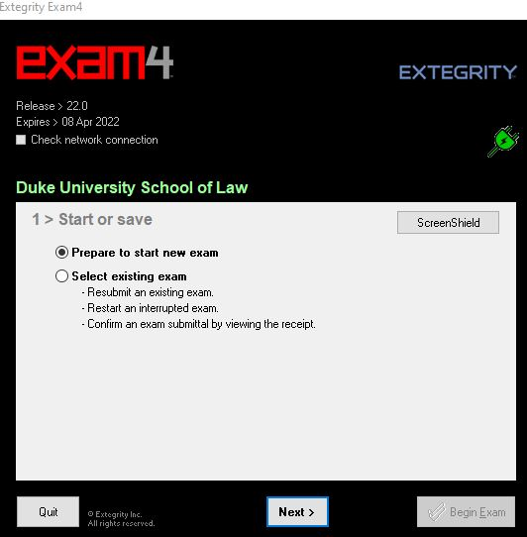

- Log into the software, enter your student id# twice. There is also a box for entering your last name. The professor will not see your name.
- 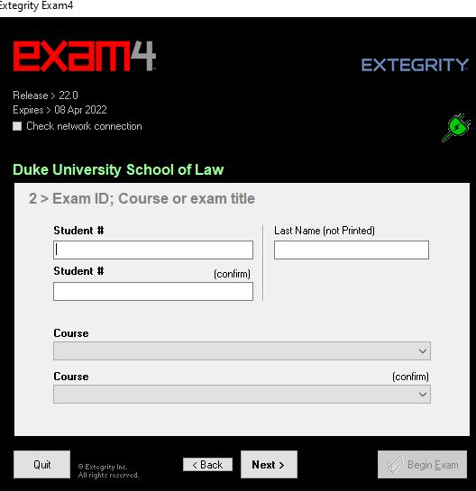

- Select the course, twice for accuracy, from the drop-down lists. If you are taking a practice exam it will say “Practice Exam” with a different one available for each mode. During the regular exam period, be certain to choose the course (for example, Law 120_01 Constitutional Law), not the practice exam. When your entries for this screen are complete, click Next. 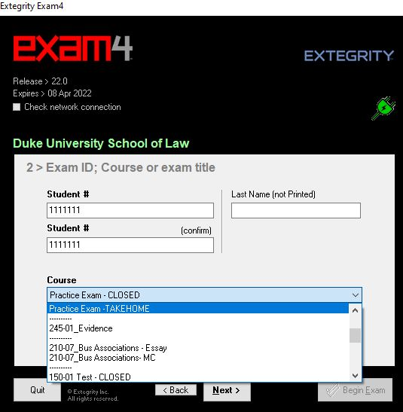

- Choose font size and color contrast. This is for your use and will not appear on the printed exam, click Next.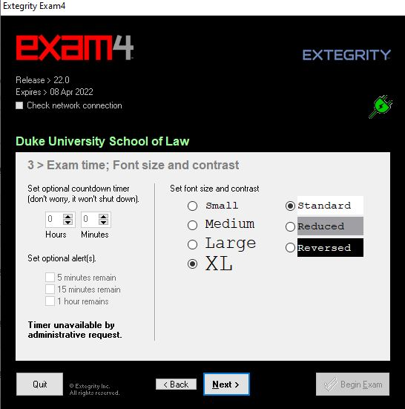

- We do not use the in-exam timer. It is disabled.

- Attest to the honor code and crash recovery procedure, then click Next.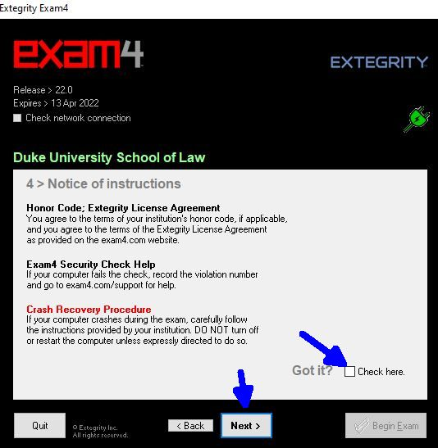

- CONFIRM that the correct mode is pre-populated in the Exam Mode field and check the box to confirm the mode, then click Next.

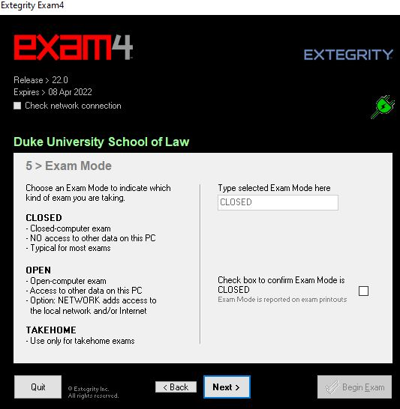

- Review your entries to CONFIRM that you entered your correct student id#, selected the correct course and that the mode is correct. If you are taking an in-person exam, wait for the proctor to call Start. Then, click Begin Exam.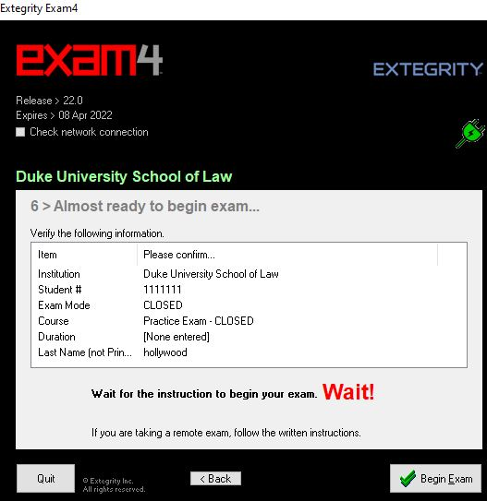

IMPORTANT: If you accidentally begin your exam before the proctor calls start, close it immediately and let the proctor know. You will then have to open a new exam file.
If you run into any error messages or violation numbers while taking a practice exam, take a screen shot of your entire computer screen with the message, make note of the steps that yielded the error or violation and contact user support via the user support form found at the bottom of the support page at https://www.exam4.com/support/ . You may also contact the Law School Help Desk at helpdesk@law.duke.edu. Be sure to include your screenshot and provide a description of the steps taken before receiving the error or violation message. During exams you will follow the general exam instructions.

TOOLS AND EDITING FUNCTIONS:
Exam4 has the standard features of a word processor, but you should familiarize yourself with the differences during your practice exams.
In the dropdown Tool menu, Exam4 has editing features, including spell check. There are a few important things to note:
- If you are using Windows, the delete key functions as it does in Word in that if you want to delete character-by-character you must put the cursor at the beginning of the text you wish to delete prior to hitting the delete key. You can also delete a group of text by highlighting the text and then hitting the delete key. If you delete more than 100 characters a warning box pops up to confirm that is your intent. Mac functions are not changed in Exam4.
- The system does not allow footnotes.
- Exam4 does not allow cut and paste into the answer field from external documents, except for Take Home Mode. You may cut, copy, paste, undo and redo within the exam answer. The commands are available in the Edit menu and with standard keyboard shortcuts. 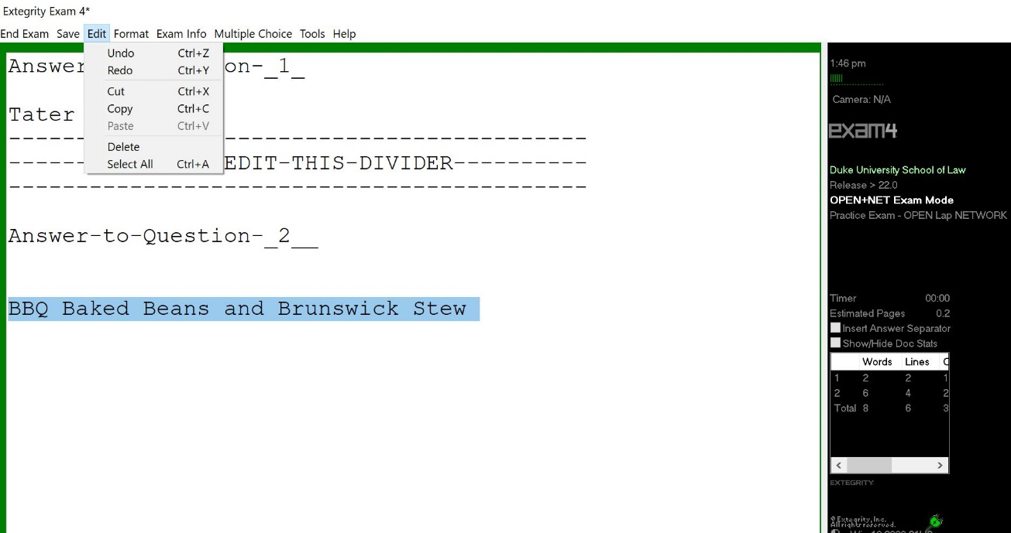

- Essay answers in Exam4 are separated using an Answer Separator. The Answer Separator provides a word count for each question. To view the word count for each question, click on “Show/Hide Document Statistics”. 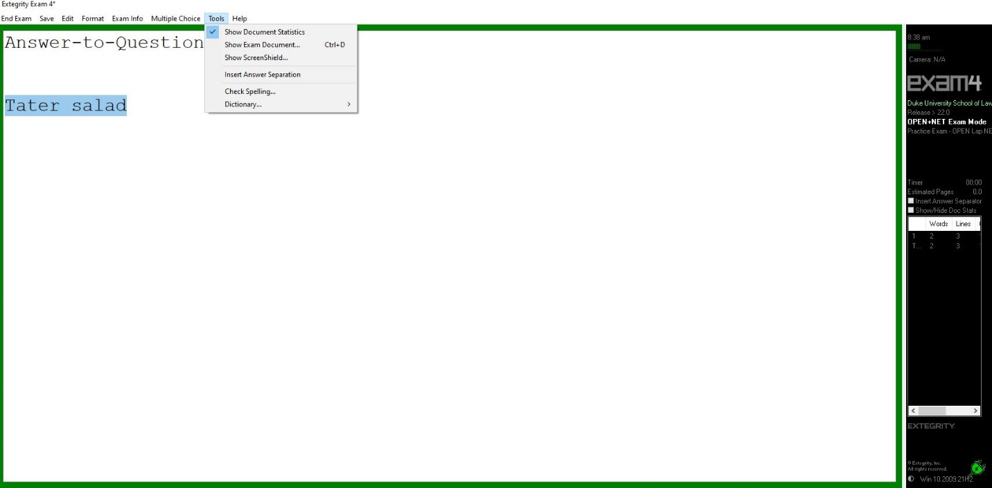
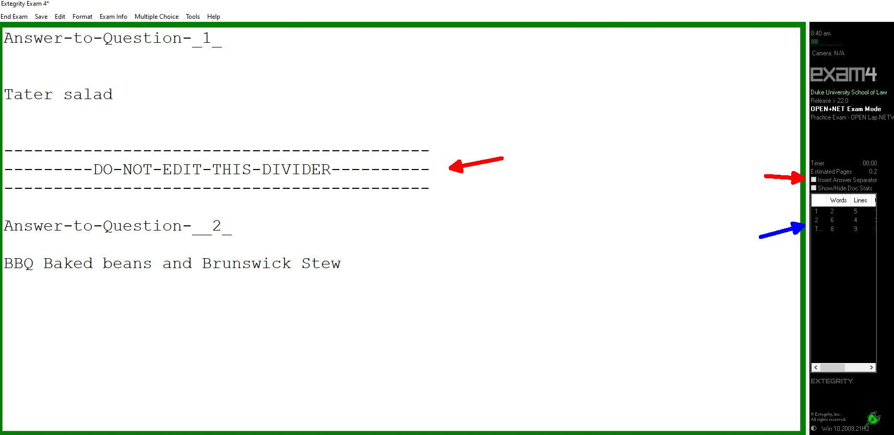

- Exam4 provides the question number for the first answer. After the first question, you must add the number, but you must not edit the Answer Separator in any other way so that the word count will be accurate. You may insert an Answer Separator using the Tools menu at the top of the window, or by clicking the box to the right of the screen.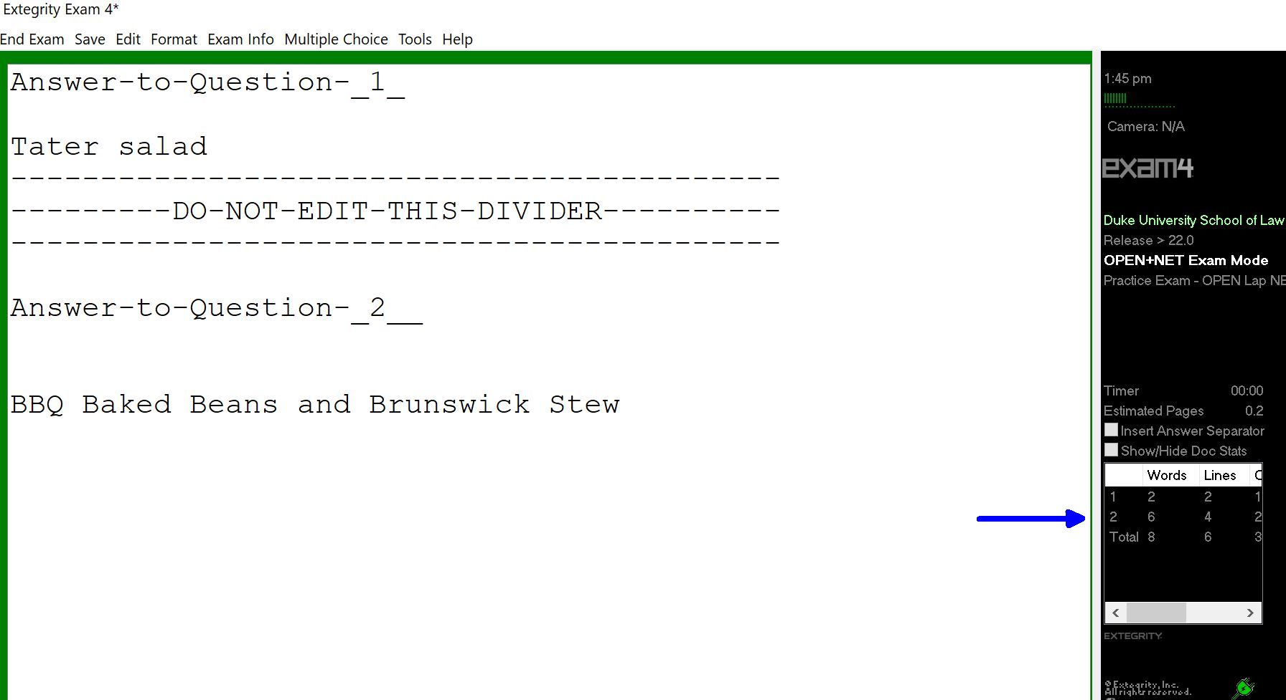

- The maximum file size for an exam in Exam4 is 40 single-spaced pages. You will receive warnings if you approach this file size. If you receive a warning that you have reached the file size limit, notify your proctor or go to the Registrar’s Office in Room 2027 of the law school. (This scenario is unlikely.)

NAVIGATING MULTIPLE CHOICE QUESTIONS
There are two ways to navigate between the questions.
- You can use the up/down arrow buttons to scroll through the questions.
- You can click directly onto the question in the list on the left.
Use the A-J button fields to answer the questions. A and B also serve as True (A) and False (B).
The “Mark” button allows you to mark a question with an * to remind you to return to the question if you are unsure of your answer and would like to review it. You can remove the * by clicking “Unmark”.
Every time you select an answer and move to the next question your answer is locked. You can change your response by clicking on the “Unlock” button to the right of the A-J fields. If you want to remove an answer, click on the “Clear” button.
As an additional safeguard, be sure to circle your answer on the paper exam questions.
When you are done answering your multiple-choice questions, click on the “Hide” button. 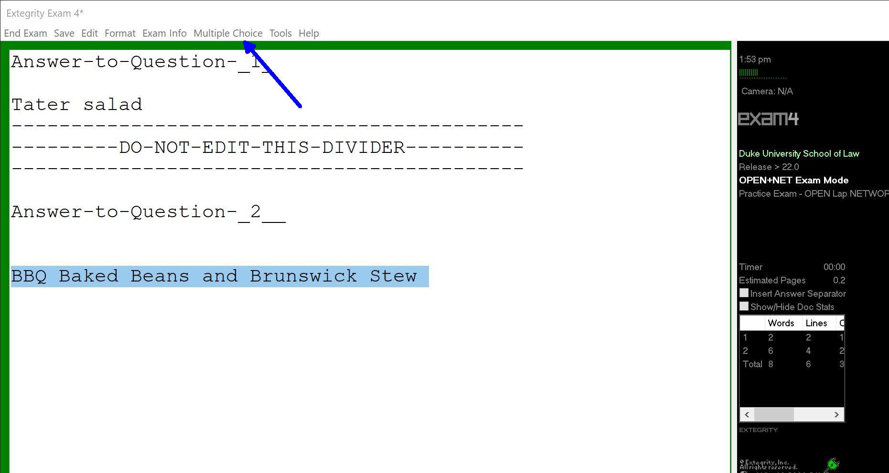
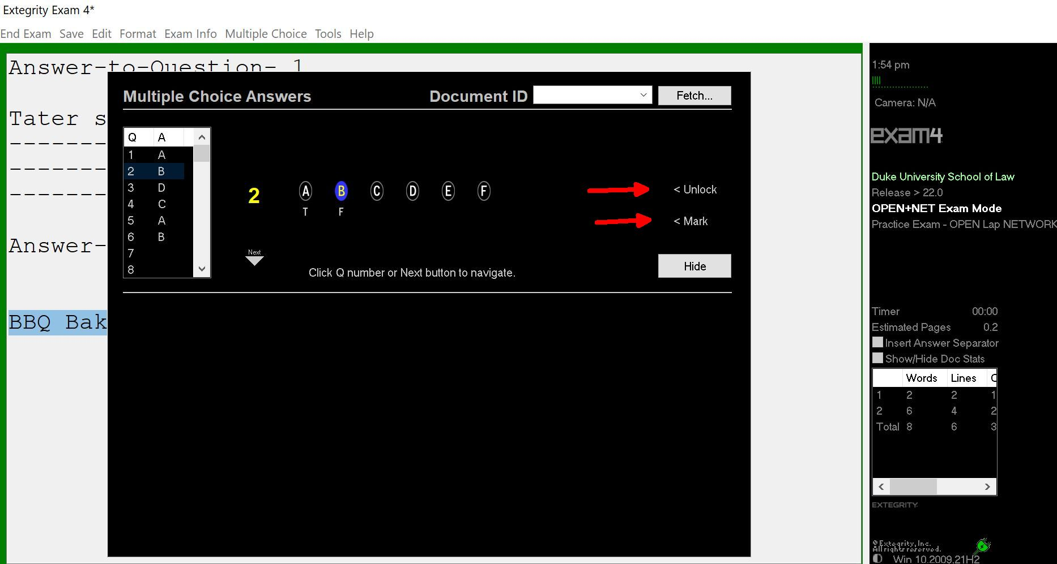
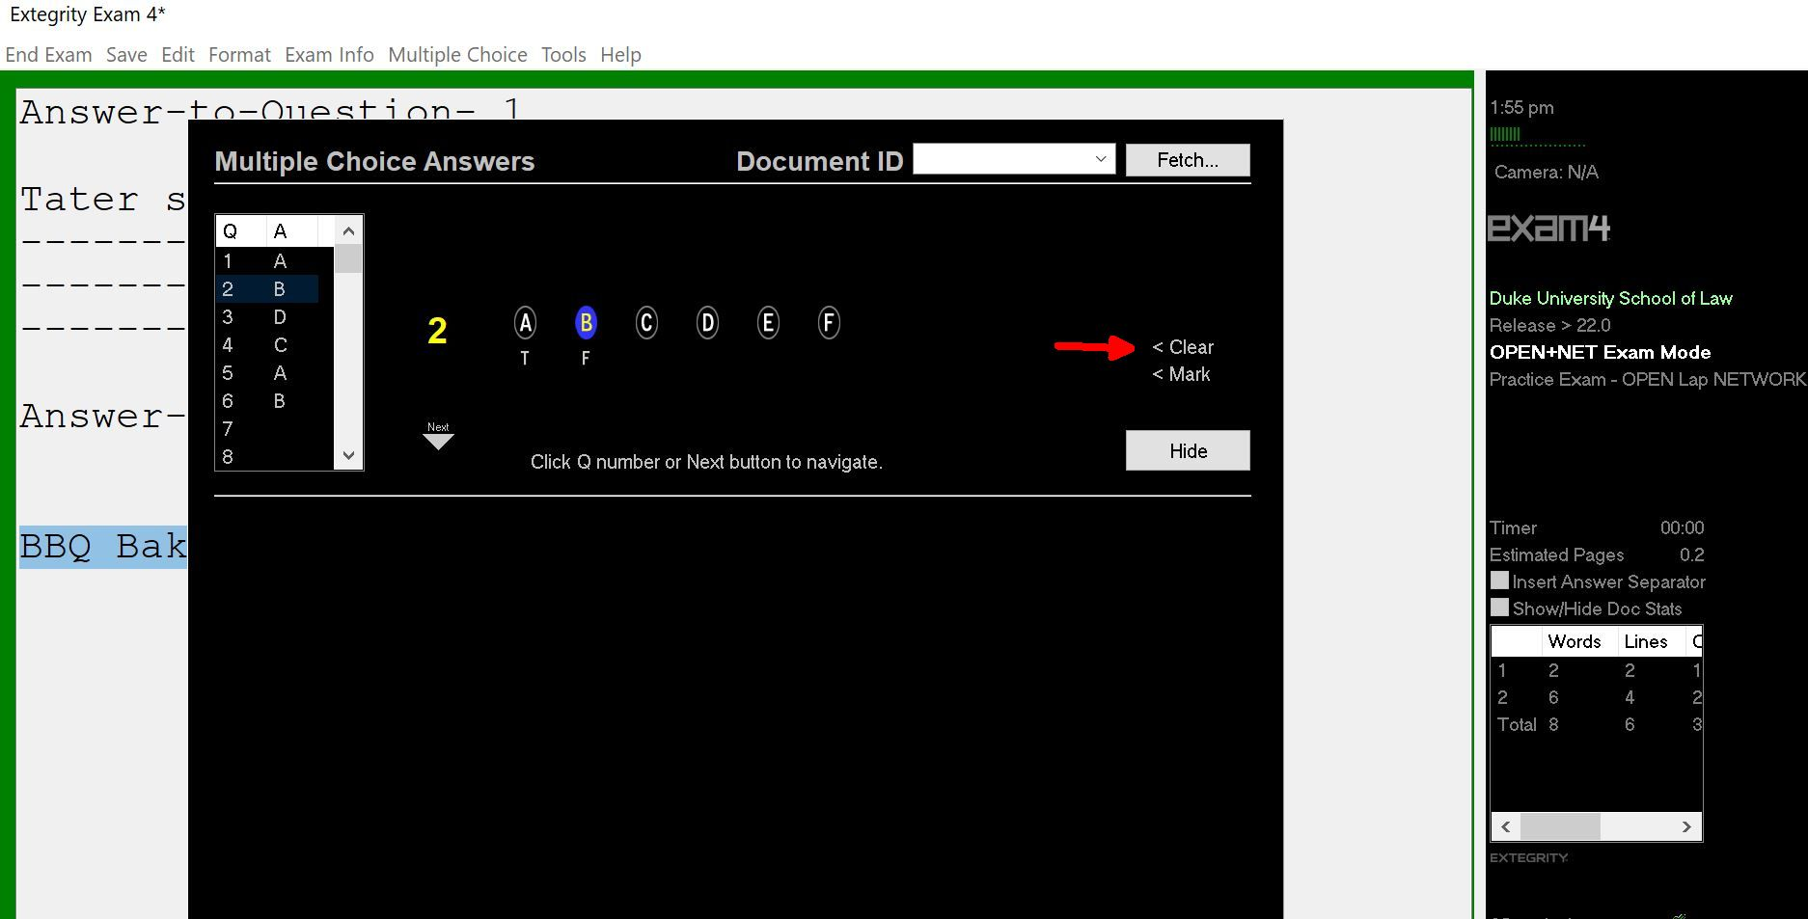
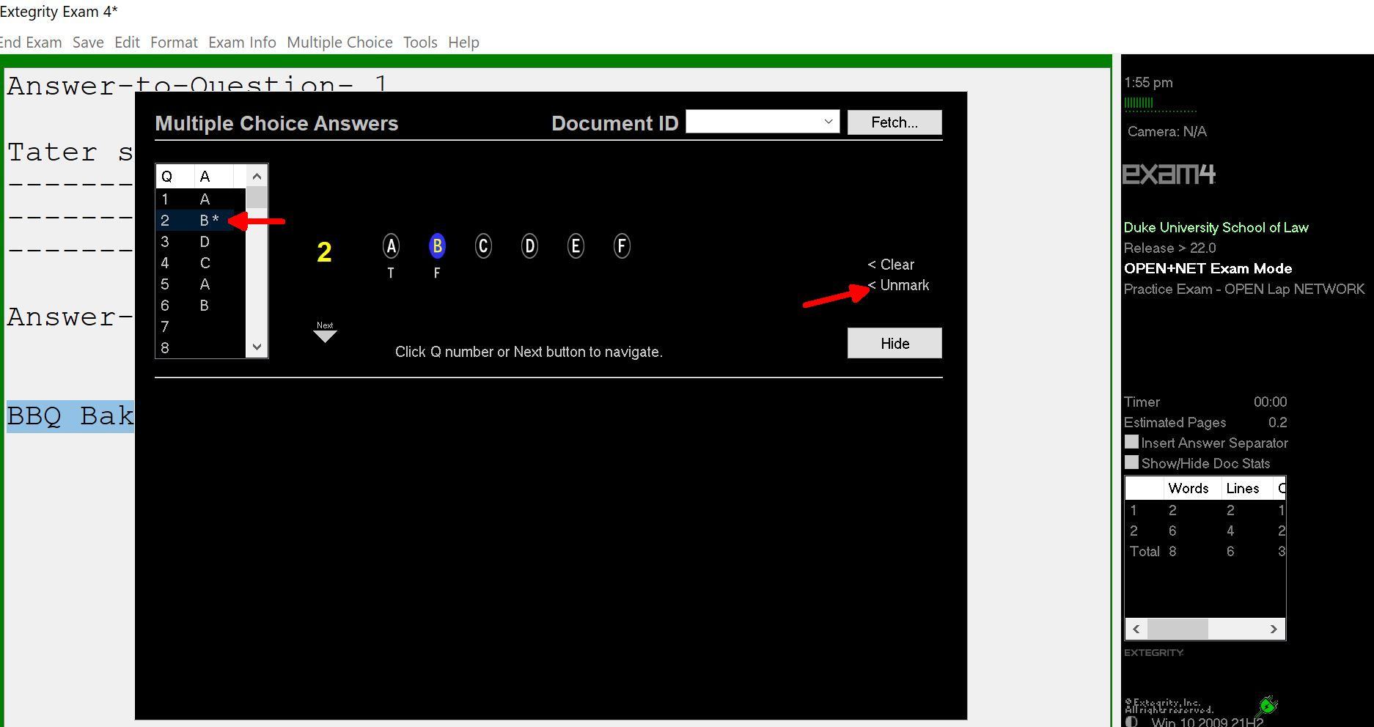

SUBMITTING YOUR EXAM
There are several steps to exit an exam in Exam4. You must follow all of them. When you have completed your exam and are ready to submit your answers, navigate to “End Exam” on the top menu and click on “End Exam Now”. (If you are in the multiple-choice section, you must click the “Hide” button first to activate the top menu). Then, end the exam. 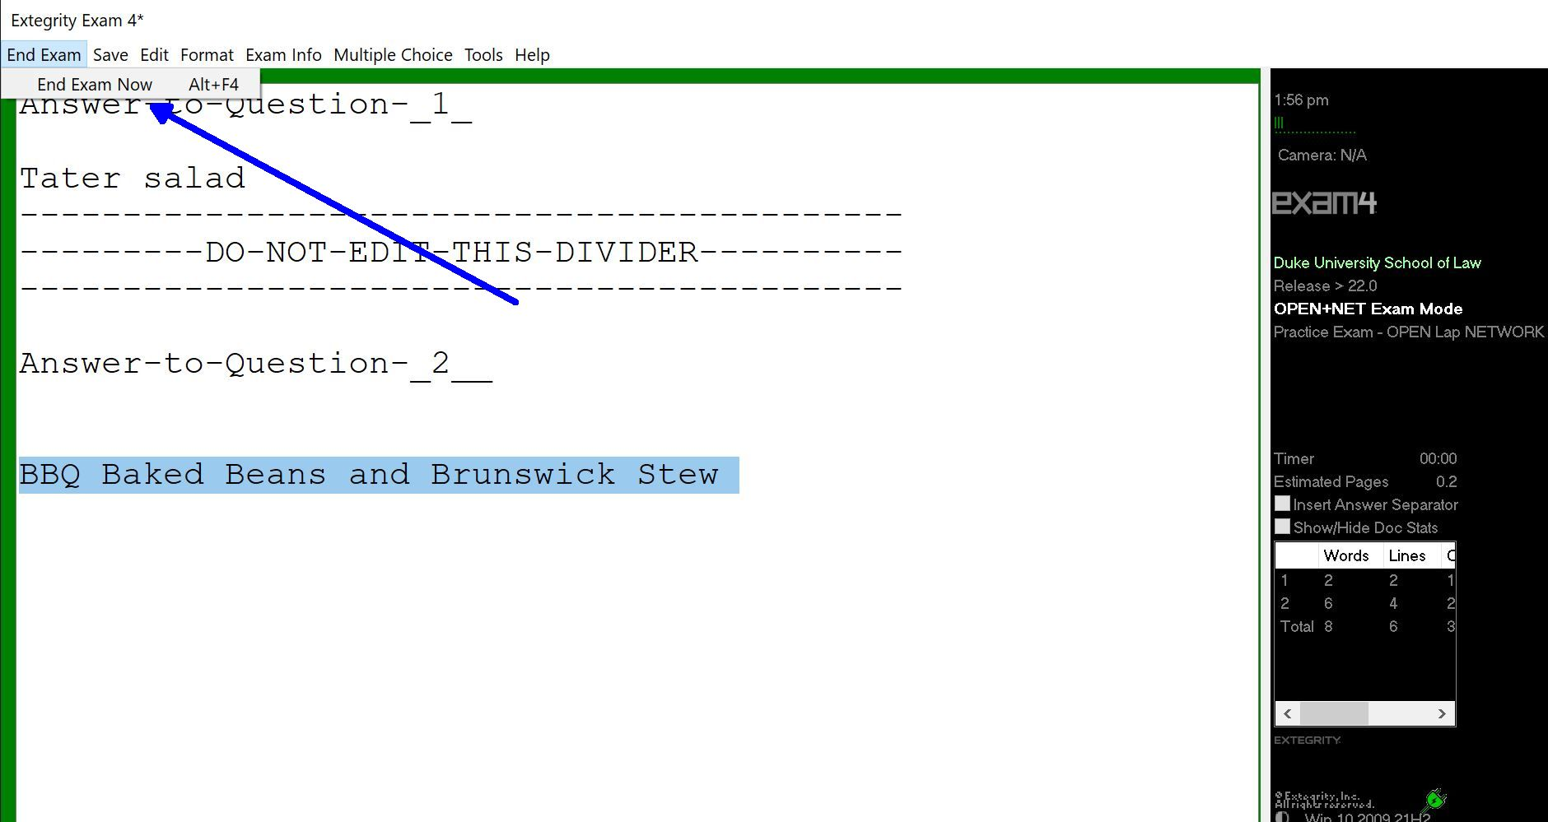
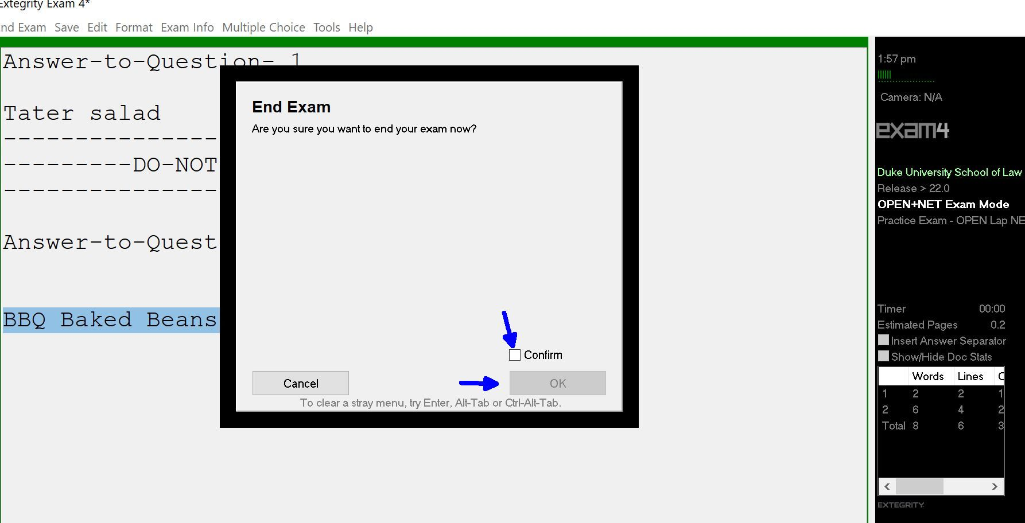
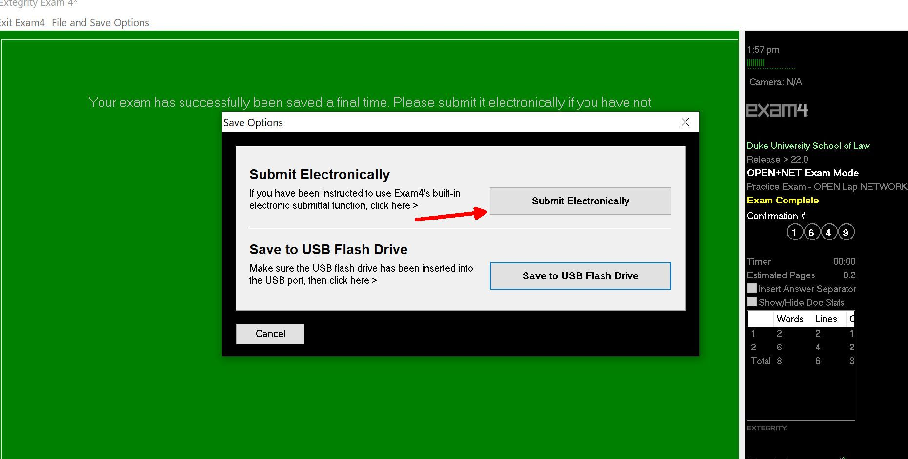
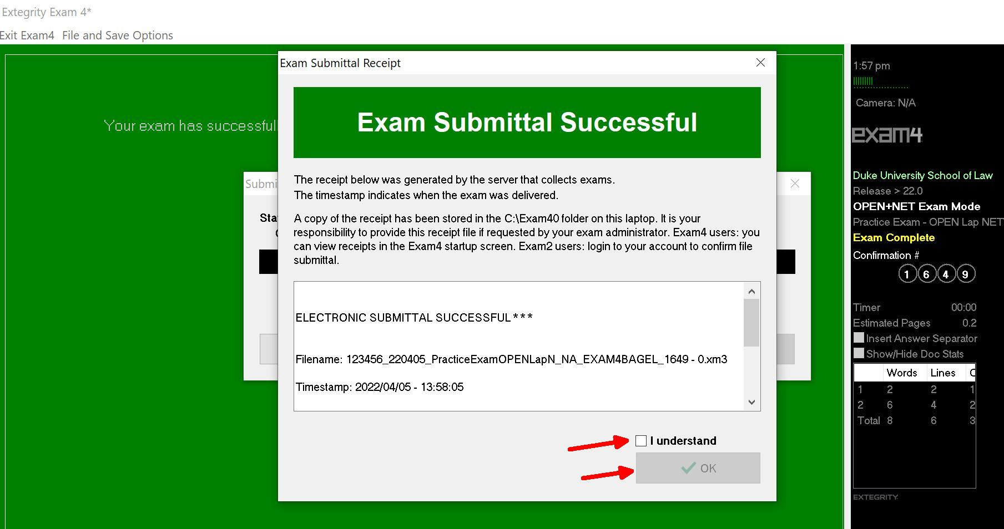
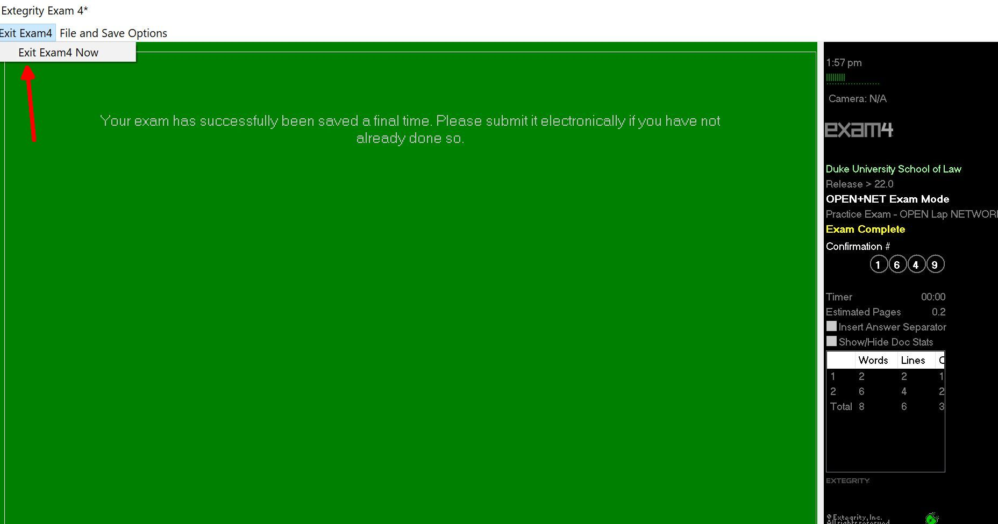
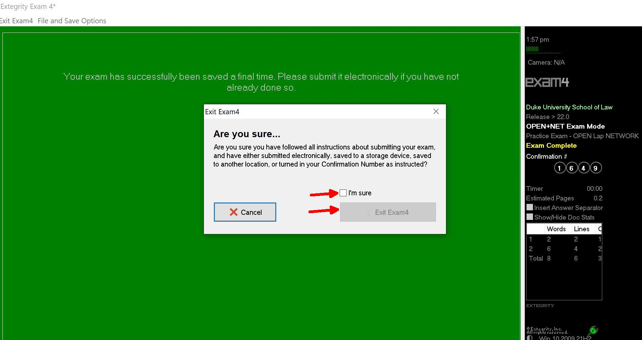

For an in-person exam, you should be preparing to submit your exam as the proctor calls the one-minute warning.
If your exam doesn’t submit, make sure that your internet is turned on. If you feel that it is taking a long time, raise your hand to alert the proctor. Duke Law Academic Technologies will be sent to the exam room to assist in submitting the exam.
An exam cannot be reopened once it is submitted. It is encrypted and cannot be viewed.

TROUBLESHOOTING in person exams:
If your computer crashes during the exam, raise your hand to alert the proctor if he or she is in the room. Do not restart your computer. Do not end your exam. If the proctor is not in the room, go to the Registrar’s Office in Room 2027 on the second floor of the law school. Leave your laptop in the exam room. In the Registrar’s Office you will receive a red sheet of paper and you will return to the exam room. Academic Technologies will be called to assist. If Academic Technologies is unable to restart your computer you may be required to handwrite the remainder of your exam.

For REMOTE exams in Exam4, the Duke Law Help Desk can be reached at helpdesk@law.duke.edu or 919-613-7072. Someone will be monitoring the email and voicemail and return your call within a few minutes.

