GENERAL EXAM INSTRUCTIONS

These are the general exam instructions that govern in-house exams. Students are expected to follow these instructions, unless they conflict with the professor’s written instructions that appear on the colored page of the exam. Failure to follow these instructions may result in an Honor Code violation.

- Getting Started
  - Turn off all cell phones and any other electronic devices that may be in your possession. None of these devices may be accessed inside or outside of the exam room during the time allotted for the exam. The only electronic device you should use is your computer, unless the device is specifically listed in your professor’s exam instructions, which are included in your exam packet.
  - Only foam earplugs provided by the exam proctors may be used in the exam room.
  - There should be at least one seat between you and your classmate.
  - Do not contact a professor directly if you have a problem before, during, or after your exam. This includes computer malfunction, illness, being unable to finish an exam, etc. Please contact the Registrar’s Office (Student Records, Rm. 2027) first so that they can assess whether your professor needs to be contacted.
  - Do not turn the colored page containing the professor’s instructions until the proctor directs you to do so.
  - If this is a CLOSED BOOK exam, please remove all materials off the top of the desk. To avoid the appearance of an Honor Code violation, please take any necessary items (snacks, pens, etc.) from your book bags and purses before the exam begins.
  - Do not put your name on any materials related to the exam. Use only your Student ID Number for identification. (This is not the number on the back of your picture ID). If you do not know your Student ID Number, you can access it through DUKEHUB at http://law.duke.edu/portal/student. Click on the DUKEHUB link near the top of the page, then enter your NetID and password. Your Student ID can be found in the Dashboard under My Profile/General Information.
  - See the included instructions for starting and using Exam4.

- During the Exam
  - If you are using Exam4, YOU MUST LAUNCH EXAM4 AT THE START OF THE EXAM. Failure to do so may result in an Honor Code violation.
  - EXAM4 DOES NOT PERMIT CUTTING AND PASTING INTO THE EXAM FROM AN EXTERNAL DOCUMENT. Do not type your exam in Word and attempt to paste it in the exam window. Type your answer directly into Exam4.
  - When approved for use in an exam, only hard-copy English translation, not law, dictionaries may be used.
  - During the exam, you are not allowed to remove any exam materials, including your computer, from the exam room. The only exception to this rule is if the Academic Technologies technicians remove the computer to work on it elsewhere.
  - If you are using Exam4 and there are multiple choice or true/false questions on your exam, please circle the correct answer on the hard copy of the exam questions, as well as entering it in Exam4. A Quick Guide to Editing Functions is attached at the end of this packet.
  - See the instructions on page 10 for what to do if you experience technical difficulties during the exam.
  - REMEMBER THE HONOR CODE

- Finishing the Exam
  - You will receive both a 5-minute and 1-minute warning. At the 5-minute mark, complete your final thoughts and begin ending your exam. At the 1-minute mark, conclude your exam and hit “End Exam” if you are using your computer or check to be sure that all blue books are labeled if you are handwriting your exam. Put all exam materials and scratch paper in the envelope, put your Student ID on the label and hand it to the proctor or place it in the box in the front of the room.
  - When time is called, stop ALL typing and writing IMMEDIATELY. Put down your pen and/or remove your hands from the keyboard. Typing or writing after time is called is a violation of the Law School’s Honor Code. If you continue to work past the allotted time, the proctor will note for the professor the time you stopped writing. If you are using Exam4, the program will record the extra time. If you have not saved your exam or you run into some other trouble with your computer after time is called, raise your hand or stand to alert the proctor. DO NOT CONTINUE TO TYPE EVEN IF YOU ARE JUST TRYING TO SAVE THE DOCUMENT.
  - Unless instructed otherwise, all exam questions must be returned in the exam envelope with your Student ID Number in the top right-hand corner. The professor may not grade your exam if these questions are missing. Removing the exam questions from the room may result in an honor code violation. Check carefully that you have put them in the envelope before leaving the room.
  - Because other students may take this exam at a later date, do not discuss it with anyone after you leave the room.
  - If you finish your exam before the proctor returns, please put your exam materials in your envelope and place the envelope in the box in front of the room. DO NOT TAKE YOUR EXAM TO THE REGISTRAR’S OFFICE (Rm. 2027).
  - After you turn in your exam, please LEAVE the room QUICKLY and QUIETLY. Since other students may still be taking the exam, do not congregate outside the exam room.
  - To avoid the appearance of an Honor Code violation, please do not remain in the exam room to check or send e-mail once you have turned in your exam.

IN CASE OF A FIRE ALARM DURING AN EXAM

If a fire alarm occurs during an exam:

- Leave the exam room and exit the building.
- Do Not take any materials, books or computers with you.
- Do Not turn off your computer.
- Do Not discuss the exam during the fire alarm.
- After the building has been cleared for re-entry, you will be given 5 minutes to return to your exam room.
- Do Not start your exam until the proctor returns to the room and instructs you to do so.
The proctor will track the time during the fire alarm, and you will be given additional time to ensure that you receive the total amount of time allocated to complete your exam.

COMPUTER INSTRUCTIONS (EXAM4)

- When you first launch Exam4, please make sure you have PREPARE TO START NEW EXAM selected. Next enter your Student Number twice (Your student number is NOT your Unique ID), as well as your Last Name in the fields provided. Then select the Course from the drop-down list. Once you have made your selections, you will receive a confirmation window. Please make sure to check the box to confirm the information you entered. Your last name will not print on the exam.
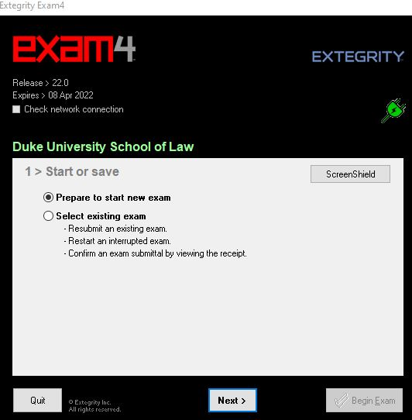
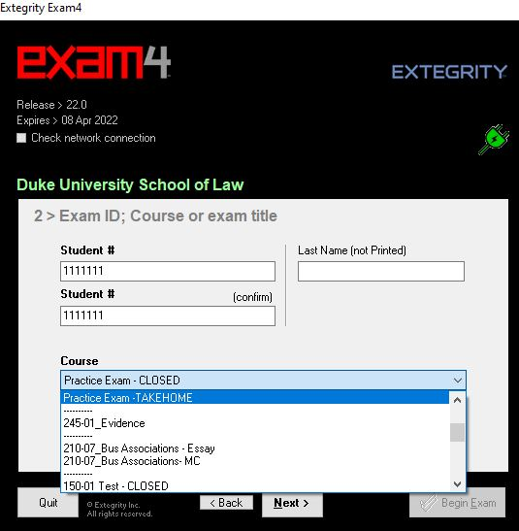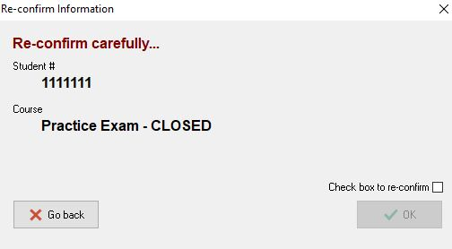
- Please select the font size and contrast in the next window. Once you click on Next, you will get a Notice of Instructions. Please read and check the box before clicking Next. In the next window, you will type in the Exam Mode. Please refer to your Exam Instructions on whether the exam you are taking is CLOSED, OPEN LAPTOP, or OPEN LAPTOP NETWORK Please type your answer in the field provided, then check the box to confirm your selection. Then click Next.
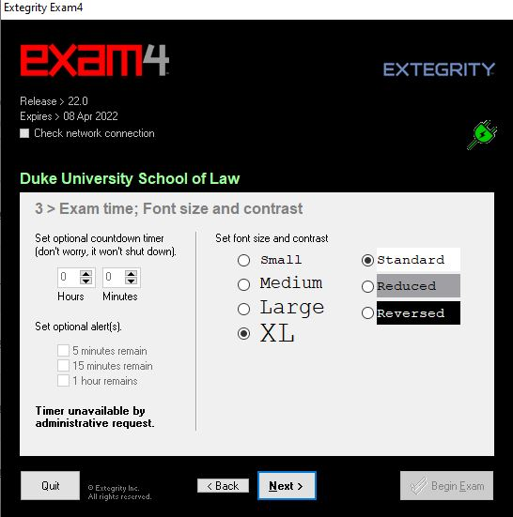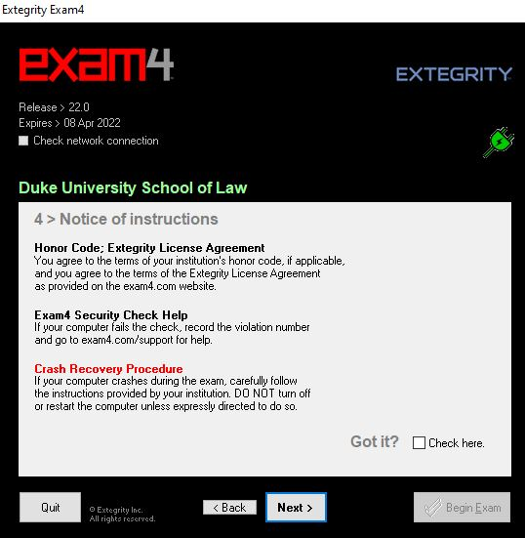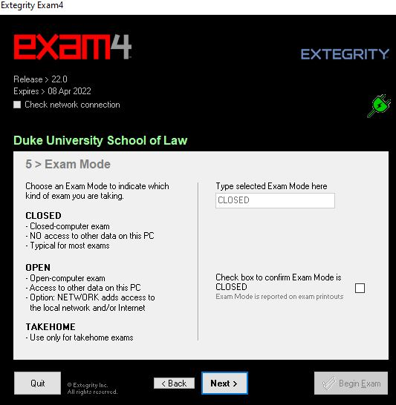
It is a violation of the honor code to perform the exam in the wrong mode. Please be sure to add the correct course and mode according to your proctor’s instructions.

The three modes for in-person exams are CLOSED, OPEN LAPTOP and OPEN LAPTOP NETWORK.
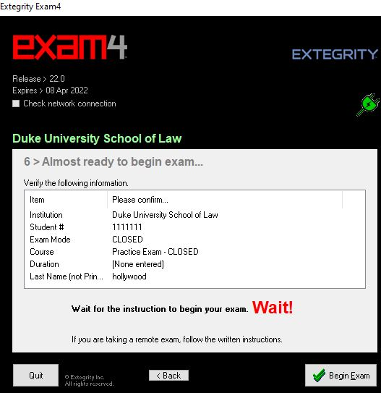

3. Do not click on the “BEGIN EXAM” button until the proctor instructs you to do so.

4. If you mistakenly hit “BEGIN EXAM” before you have been instructed to do so, immediately hit “END EXAM” in the upper left corner and begin the process again. Inform the proctor that this problem occurred so that the proctor can alert the Registrar to look for two Exam4 files from you.

5. You MUST type the exam in Exam4. You cannot copy/paste from a separate application such as Word into Exam4. Please leave time at the end to use spell check and other tools.

6. If your computer equipment fails during the exam, note the time of the equipment failure and how much of the exam you had completed at the time of the failure. You have two options for proceeding:

(a) You may immediately obtain a blue book (which will be available in the examination room) and continue where your computer stopped and complete your exam by hand. If you choose this option, notify the proctor or Registrar's Office of the equipment malfunction immediately following the exam. DO NOT REMOVE YOUR COMPUTER FROM THE EXAM ROOM OR TURN OFF YOUR COMPUTER.

(b) If your computer fails and you wish to seek immediate assistance with the computer, you should notify the proctor or, if the proctor is not in the examination room, go to the Registrar's Office. DO NOT REBOOT. DO NOT TURN OFF YOUR COMPUTER OR REMOVE IT FROM THE ROOM. DO NOT GO TO THE ACADEMIC TECHNOLOGIES HELP DESK. Either the proctor or the Registrar's Office will contact Academic Technologies staff for assistance. If Academic Technologies cannot resolve the issue in the allotted time, you will need to handwrite the rest of your exam in a traditional blue book.

Do not use valuable exam time to attempt to resolve the problem yourself. When you report the problem to the Registrar’s Office or Proctor, you will receive a red-colored note that should be placed on your desk and should be visible to the proctor. The note will be marked with the time you reported the problem, the time the technicians ended their attempt to resolve the problem and the amount of extra time you will receive—not to exceed a total of 20 minutes. Once the computing problem is resolved, begin with the question from where your troubles began.

If appropriate, the Registrar will print a hard copy of the work you completed on your exam up to the point of the computer failure and allow you to take the hard copy with you back to the exam room.

7. When you are finished with your exam, click on “END EXAM” in the upper left corner. You will be prompted for confirmation. Check the box, then click on Ok. If you have trouble submitting the exam, let your proctor know, or, if a proctor is not in the room, come to the Registrar’s Office and Academic Technologies will be called to assist you.

8. Collect your exam questions and any scrap paper you may have used. Place these materials in the exam envelope and turn it in to the proctor or place it in the box in the front of the room.

9. Please be considerate of your fellow students if you finish early: leave the room quietly and do not discuss the exam with anyone.

QUICK GUIDE TO EDITING AND MULTIPLE CHOICE
Students should have downloaded Exam4 and practiced before the exam day, and received a detailed guide for that purpose. This is intended as a reminder.
Exam4 has the standard features of a word processor.

In the dropdown Tool menu, Exam4 has editing features, including spell check. There are a few important things to note:
- If you are using Windows, the delete key functions as it does in Word in that if you want to delete character-by-character you must put the cursor at the beginning of the text you wish to delete prior to hitting the delete key. You can also delete a group of text by highlighting the text and then hitting the delete key. If you delete more than 100 characters a warning box pops up to confirm that is your intent. Delete for Mac computers functions in the usual way.
- The system does not allow footnotes.
- Exam4 does not allow cut and paste into or out of the answer field from external documents. You may cut, copy, paste, undo and redo within the exam answer. The commands are available in the Edit menu and with standard keyboard shortcuts.
- Essay answers in Exam4 are separated using an Answer Separator. The Answer Separator can be found under “Tools” at the top of the document window. The Answer Separator provides a word count for each question. To view the word count for each question, click on “Show/Hide Document Statistics”. The word count will not function if the Answer Separator is edited in any way. Only the question number may be added.

NAVIGATING MULTIPLE CHOICE QUESTIONS

There are two ways to navigate between the questions.
- You can use the up/down arrow buttons to scroll through the questions.
- You can click directly onto the question in the list on the left.
Use the A-J button fields to answer the questions. A and B also serve as True (A) and False (B).
The “Mark” button allows you to mark a question with an * to remind you to return to the question if you are unsure of your answer and would like to review it. You can remove the * by clicking “Unmark”.
Every time you select an answer and move to the next question your answer is locked. You can change your response by clicking on the “Unlock” button to the right of the A-J fields. If you want to remove an answer, click on the “Clear” button.
As an additional safeguard, be sure to circle your answer on the paper exam questions.

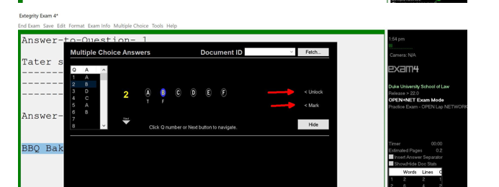
SUBMITTING YOUR EXAM
When you have completed your exam and are ready to submit your answers, navigate to “End Exam” on the top menu and click on “End Exam Now”. If you are in the multiple-choice section, you must click the “Hide” before you can access the End Exam command on the menu.
Exam4 will ask you to confirm your intention to exit the exam before you are able to exit the exam. Once confirmed, you will end the exam. You should see this screen, but it is not the last step. Click on “I understand” and then continue through the next confirmation screens until you have fully exited the software.
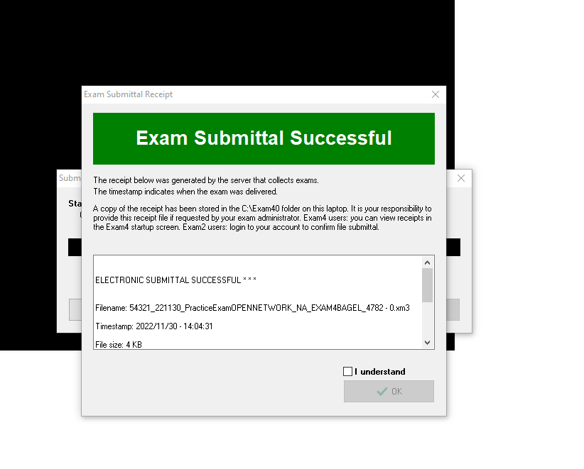
If assistance is needed, Academic Technologies will be sent to the room.

HANDWRITING INSTRUCTIONS (BLUE BOOKS)

- Before the exam begins, put your Student ID Number, course name, and professor’s name on the blue books you expect to use (usually 1 blue book per question) and on the envelope provided. Also put your Student ID Number on the envelope label. Do not write your name on anything. If you do not do this before the exam begins, you will need to do it during the one-minute warning period.

- Write on every other line and use only one side of each page of the blue book(s).

- Begin the answer to each question in a separate blue book.

- Be sure to indicate the number of the question you are answering.

- If you are using blue books, you may not use your computers unless the professor has authorized the use of computer files and/or the internet.

- At the end of the exam, collect all materials (the exam, all scrap paper, and your blue books), place them in the envelope provided and write “blue books” on the front of the envelope. If you use additional blue books, be sure you have labeled them. Number your blue books (ex. 1of 4, etc.).

- Please be considerate of your fellow students if you finish early. Leave the room quietly and do not discuss the exam with anyone.

THANK YOU and GOOD LUCK!

