WHAT IS EXAM4?
Exam4 is a word processing program, like Microsoft Word, that you will use to write in-class exams. The software is downloaded each semester. For in-class exams you will receive a hard copy of your questions and the answers will be typed and returned (electronically submitted) via Exam4.
The Exam4 system is a secure environment for exam administration and is used widely by law schools and bar examiners. The software automatically saves the exam every 10 seconds and backs up to your hard drive every two minutes.
In Spring 2022 Duke Law will use Exam4 for a limited number of exams. An updated exam schedule will be posted with additional information about the classes using Exam4. Only students in classes using Exam4 this semester need to download the software.
For FALL 2022 you MUST download the software, then take and submit a practice exam for each format of exam you are taking after the Registrar notifies you the software is available. This will allow you to troubleshoot any potential issues you might have using the software on your computer prior to your first actual exam using Exam4. Students taking the exam during the week of December 6th are encouraged to download as early as possible.
You MUST take a practice exam for each exam mode you will use (details below).
HOW TO GET STARTED IN EXAM4
- Close all programs and files, plug your computer into power and confirm that your operating system is one of the supported versions in Exam4. https://www.exam4.com/support/
- Restart your computer.
- Go to https://exam4.com. Type in Duke in the Search field and hit your Enter key. Under the Law School heading, click on Duke University School of Law.
- On the page that opens, enter your information and select your operating system, then click Continue.
- The next page opens with a blue Download Exam4 button for the operating system you selected on the previous page AND a tutorial video for taking a Practice exam. Click on the blue Download button.
- On the pop-up that opens, click the Save button to save the software executable.
- Click the downloaded file and follow the on-screen instructions to install and execute the Exam4 software.
- The software will open with an instructions screen for taking a practice exam.
- BEFORE proceeding with taking a practice exam, go back to the web page that had the tutorial video and watch it.
- You may start practice exams at this point. Only select Practice exam titles when taking a practice exam.
It is particularly important that you take a practice exam to ensure that the Exam4 software is properly installed, and you have no technical issues.
Remember to use your student id # for your practice exams and for your actual exams. Your student id is found in DukeHub, and is the same number you’ve used for previous exams. For most students it begins with a 2.
IMPORTANT NOTE: Practice exams are not available for review, so please do not do substantive work in a practice exam in Exam4.

EXAM MODES
There are three exam modes:
CLOSED: Blocks access to all other programs and the internet.
OPEN: Blocks access to the internet but access to hard drive is permitted. This means that outlines and notes must be saved to the hard drive in order to be accessible on your laptop.
OPEN + NETWORK: Complete Access to your computer and the internet.

Important: Exam4 runs a security check at the beginning of a CLOSED exam to verify that the laptop is not connected to the internet and the hard drive is not accessible. Even if you have taken a practice exam in closed mode, you should open the software in closed mode before your exam day to check for security issues. You will not be able to take your exam until the security issue is resolved. You may be required to handwrite or use a different computer.

Only one monitor may be used with this software. Having a second monitor attached will cause your computer to fail the security check.

(Continued on next page)
- Prepare to start new exam Next 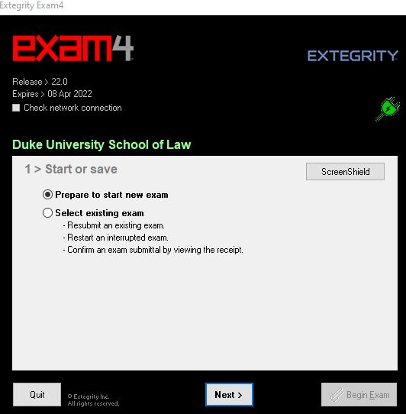

- Log into the software, enter student id (found in Duke Hub). There is also a box for entering your last name. The professor will not see your name. It will help us if you enter your student id number incorrectly. 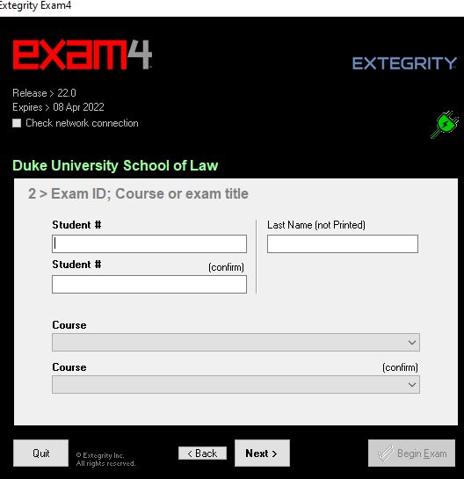

- Select the course, twice for accuracy, from the drop-down lists. If you are taking a practice exam it will say “Practice Exam” with a different one available for each mode. During the regular exam period, be certain to choose the correct course. When your entries for this screen are complete, click Next. 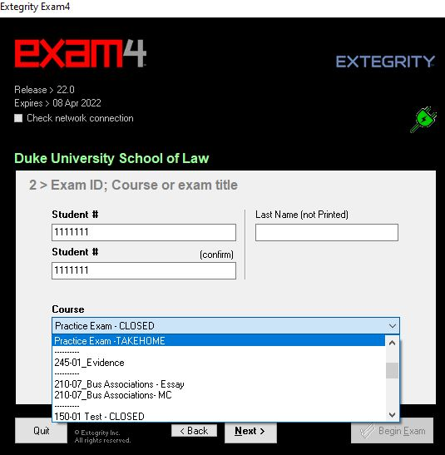

- We will not be using Exam4 for any take-home exams this semester and we will not attach any documents for taking the exam. All questions will be provided by the proctor in the exam room.
- Choose font size and color contrast. This is for your use and will not appear on the printed exam, click Next.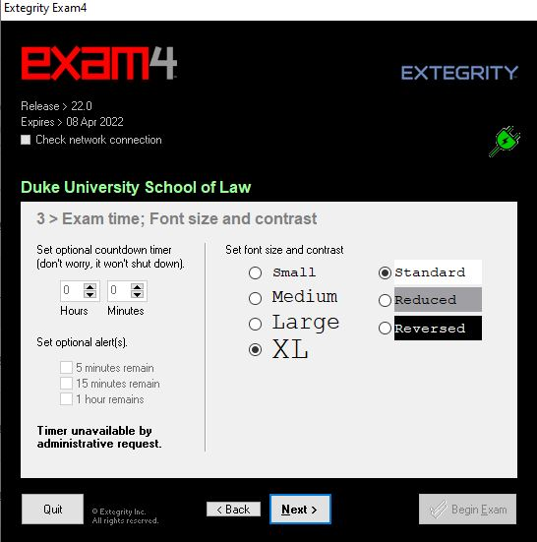

- We will not use the in-exam timer. It is disabled.

- Attest to the honor code and crash recovery procedure, then click Next.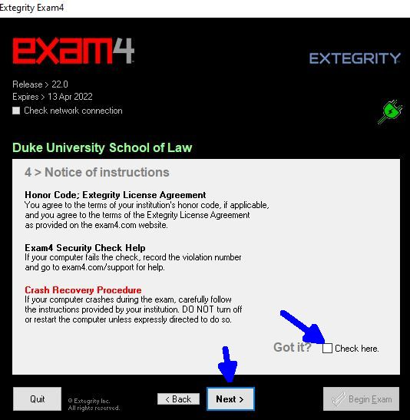

- CONFIRM that the correct mode is pre-populated in the Exam Mode field and check the box to confirm the mode, then click Next.

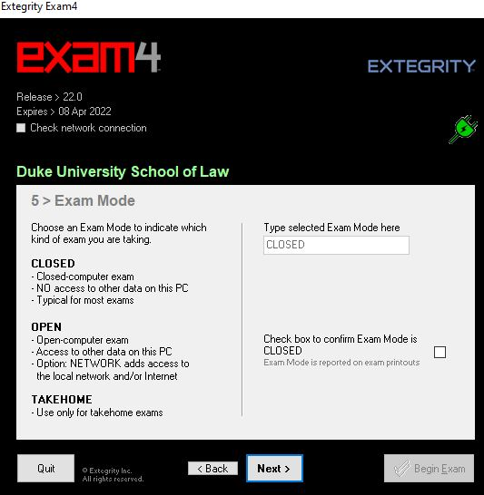

- Review your entries to CONFIRM that you entered your correct student id, selected the correct course and that the mode is correct. If you are taking an actual exam, wait for the proctor to call Start. Then, click Begin Exam.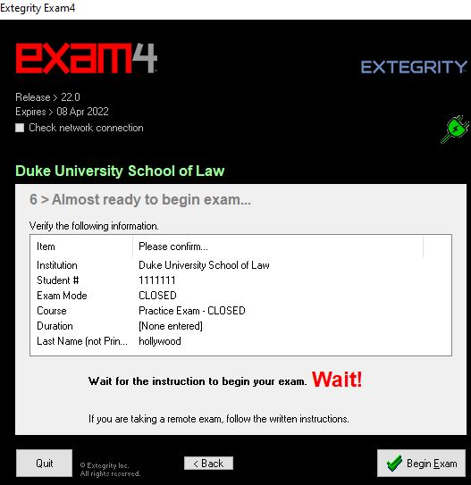

IMPORTANT: Once you exit your exam you will not be able to re-open it. If you accidentally begin your exam before the proctor calls start, close it immediately and let the proctor know. You will then have to open a new exam file.
If you run into any error messages or violation numbers while taking a practice exam, take a screen shot of your entire computer screen with the message, make note of the steps that yielded the error or violation and contact user support via the user support form found at the bottom of the support page at https://www.exam4.com/support/ . You may also contact the law school Help Desk at helpdesk@law.duke.edu. Be sure to include your screen shot and provide a description of the steps taken before receiving the error or violation message. During exams you will follow the general exam instructions.

TOOLS AND EDITING FUNCTIONS:
Exam4 has the standard features of a word processor, but you should familiarize yourself with the differences during your practice exams.
In the dropdown Tool menu, Exam4 has editing features, including spell check. There are a few important things to note:
- If you are using Windows, the delete key functions as it does in Word in that if you want to delete character-by-character you must put the cursor at the beginning of the text you wish to delete prior to hitting the delete key. You can also delete a group of text by highlighting the text and then hitting the delete key. If you delete more than 100 characters a warning box pops up to confirm that is your intent.
- The system does not allow footnotes.
- Exam4 does not allow cut and paste into or out of the answer field from external documents. You may cut, copy, paste, undo and redo within the exam answer. The commands are available in the Edit menu and with standard keyboard shortcuts. 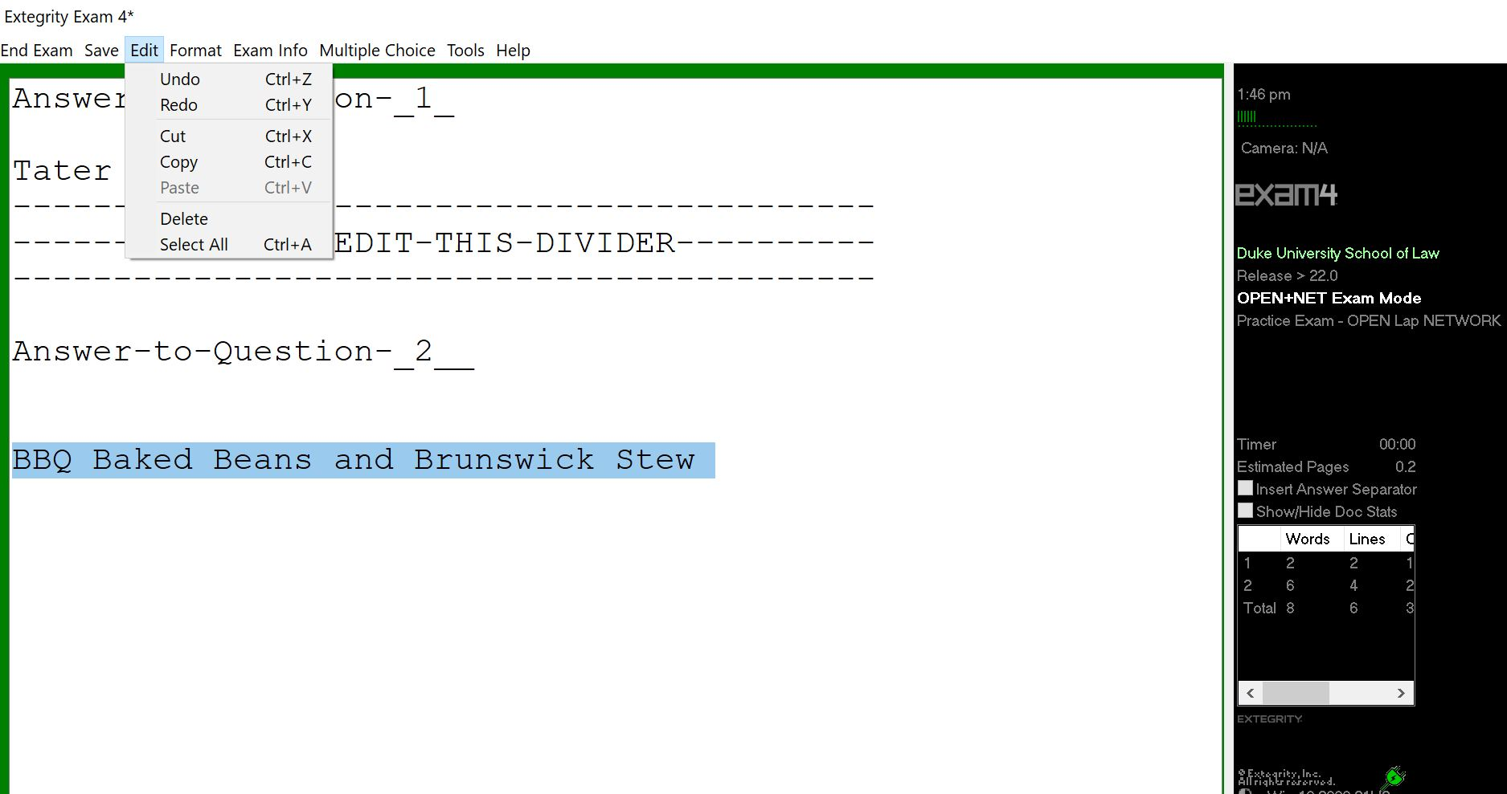

- Essay answers in Exam4 are separated using an Answer Separator. The Answer Separator provides a word count for each question. To view the word count for each question, click on “Show/Hide Document Statistics”. 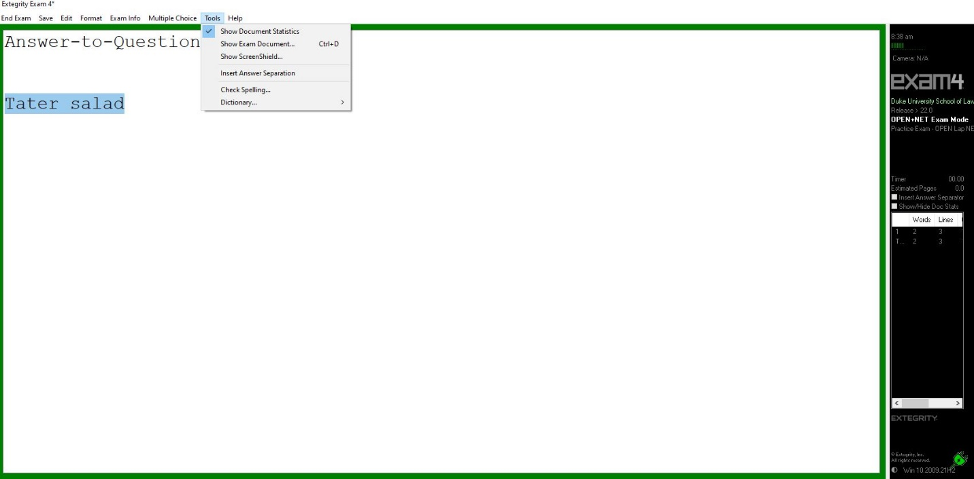
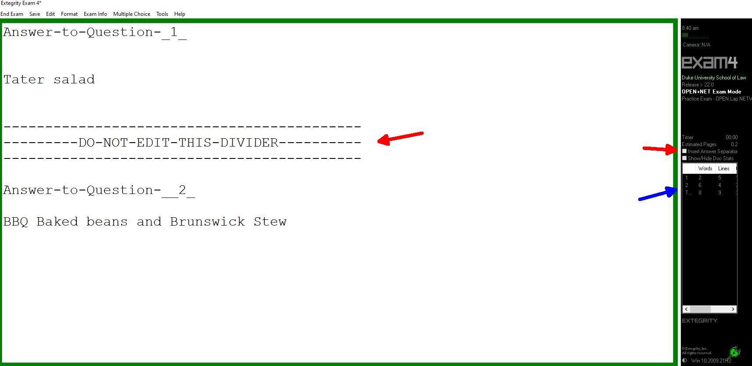

- Exam4 provides the question number for the first answer. After the first question, you must add the number, but you must not edit the Answer Separator in any other way so that the word count will be accurate.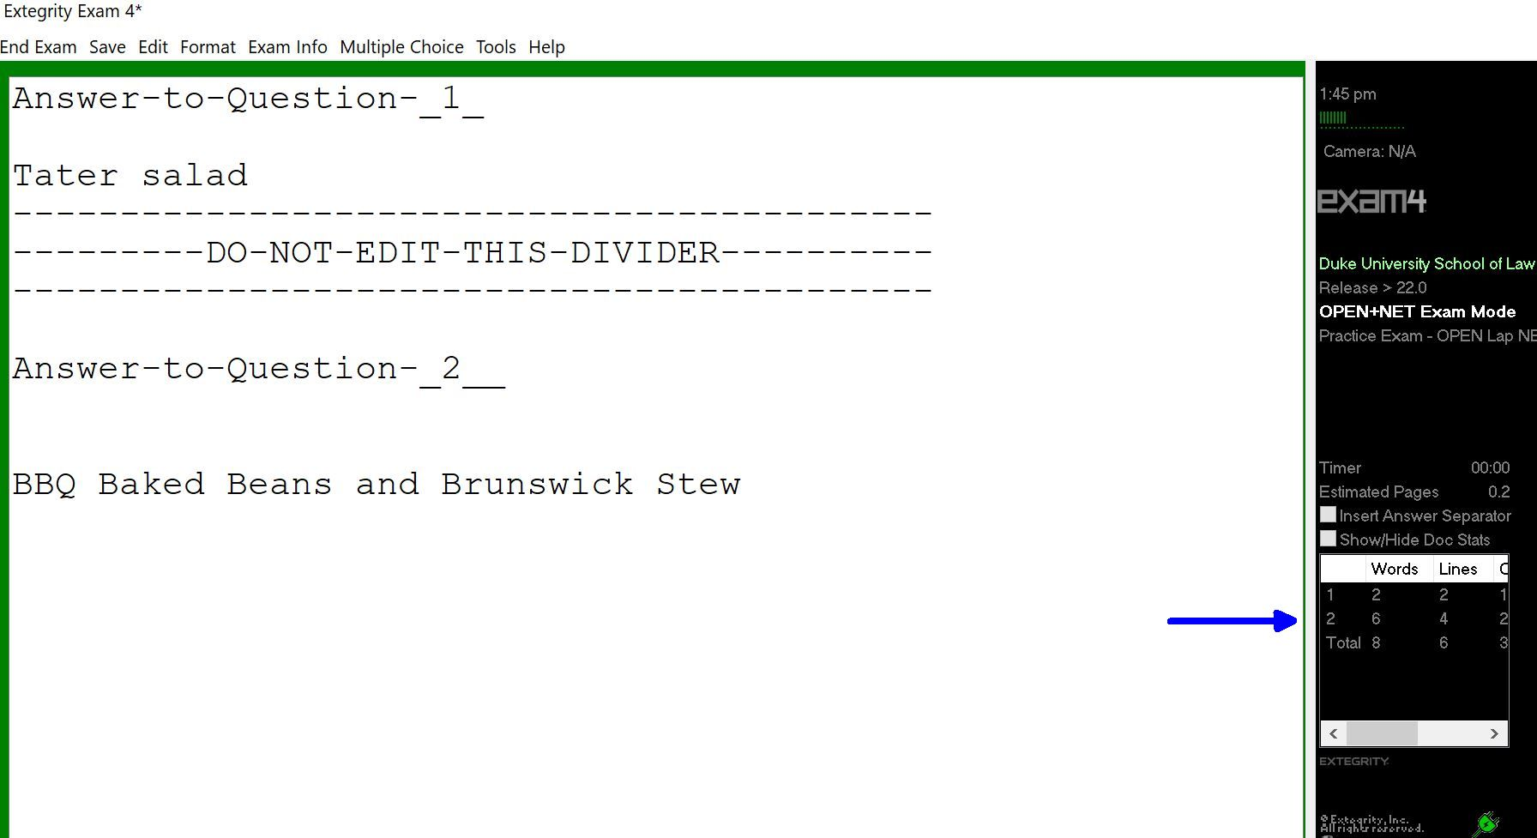

- The maximum file size for an exam in Exam4 is 40 single-spaced pages. You will receive warnings if you approach this file size. If you receive a warning that you have reached the file size limit, notify your proctor or go to the Registrar’s Office in Room 2027 of the law school.

NAVIGATING MULTIPLE CHOICE QUESTIONS
There are two ways to navigate between the questions.
- You can use the up/down arrow buttons to scroll through the questions.
- You can click directly onto the question in the list on the left.
Use the A-F button fields to answer the questions. A and B also serve as True (A) and False (B).
The “Mark” button allows you to mark a question with an * to remind you to return to the question if you are unsure of your answer and would like to review it. You can remove the * by clicking “Unmark”.
Every time you select an answer and move to the next question your answer is locked. You can change your response by clicking on the “Unlock” button to the right of the A-F fields. If you want to remove an answer, click on the “Clear” button.
As an additional safeguard, be sure to circle your answer on the paper exam questions.
When you are done answering your multiple-choice questions, click on the “Hide” button. 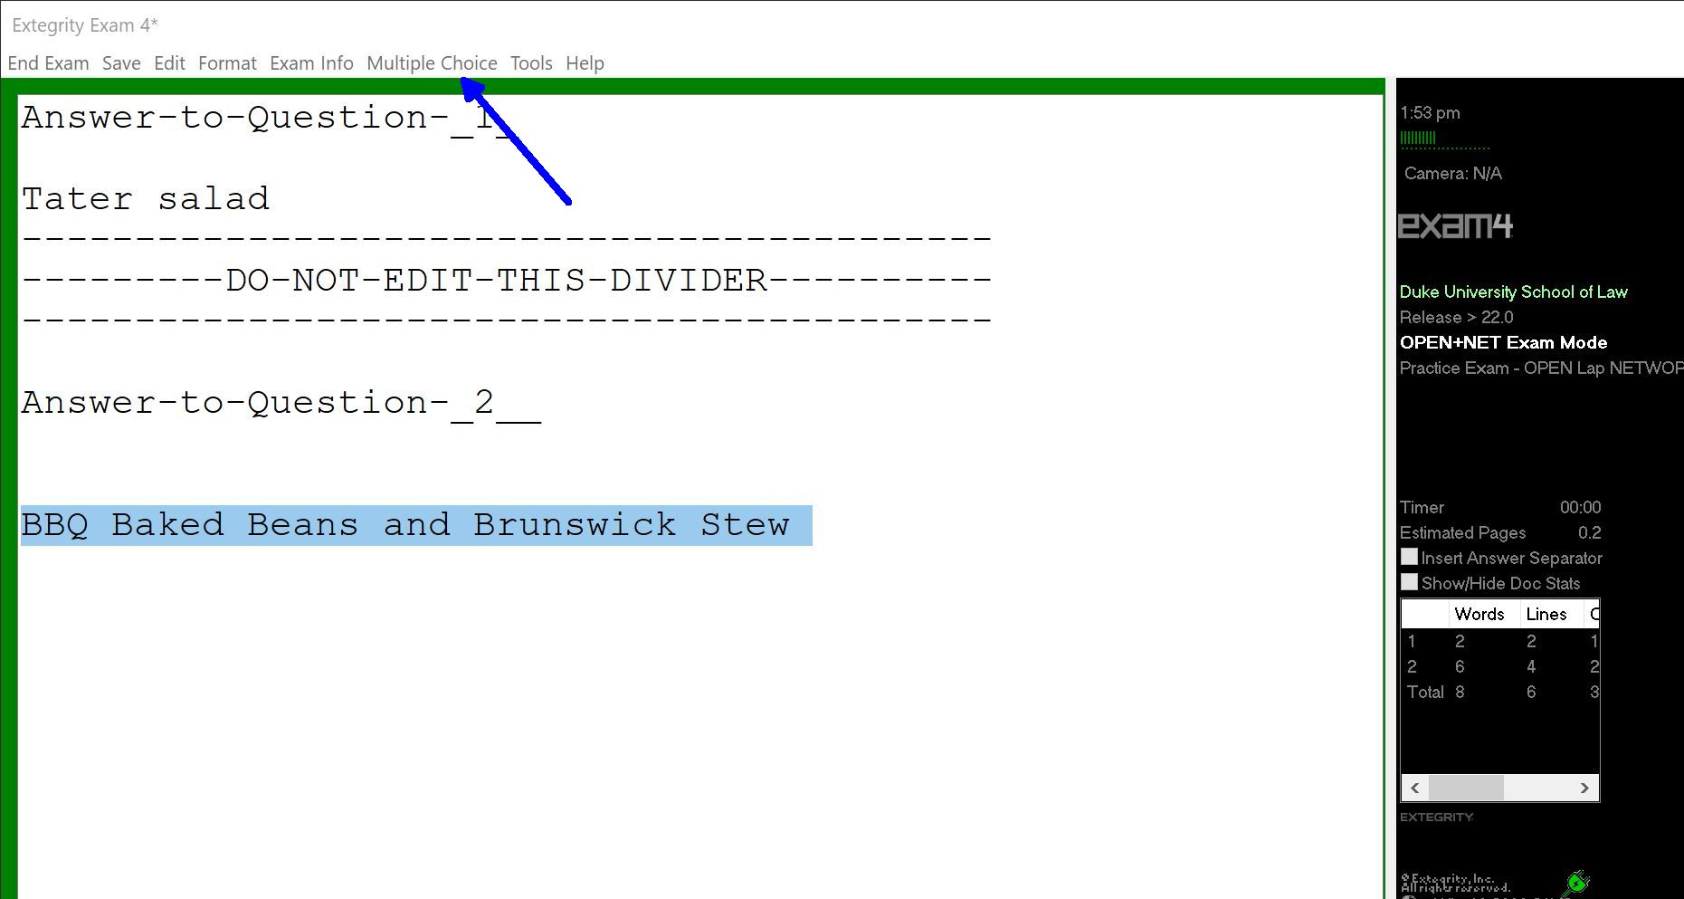
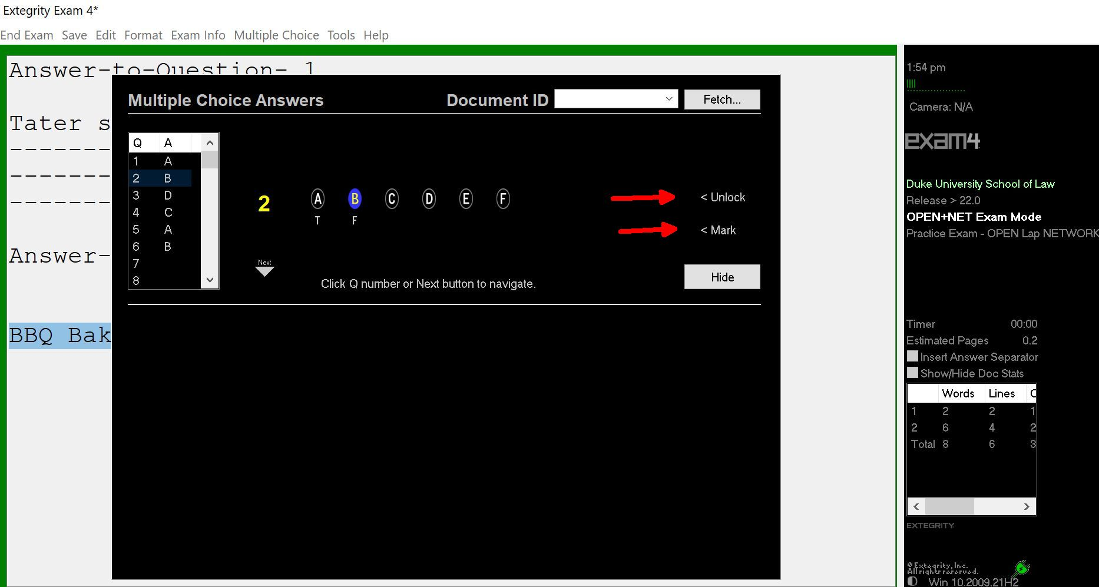
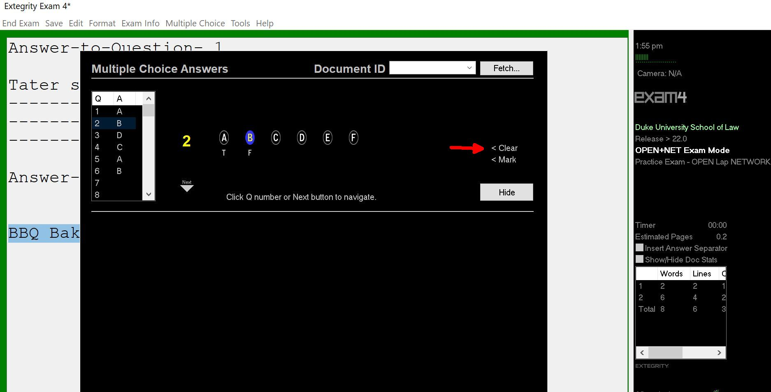
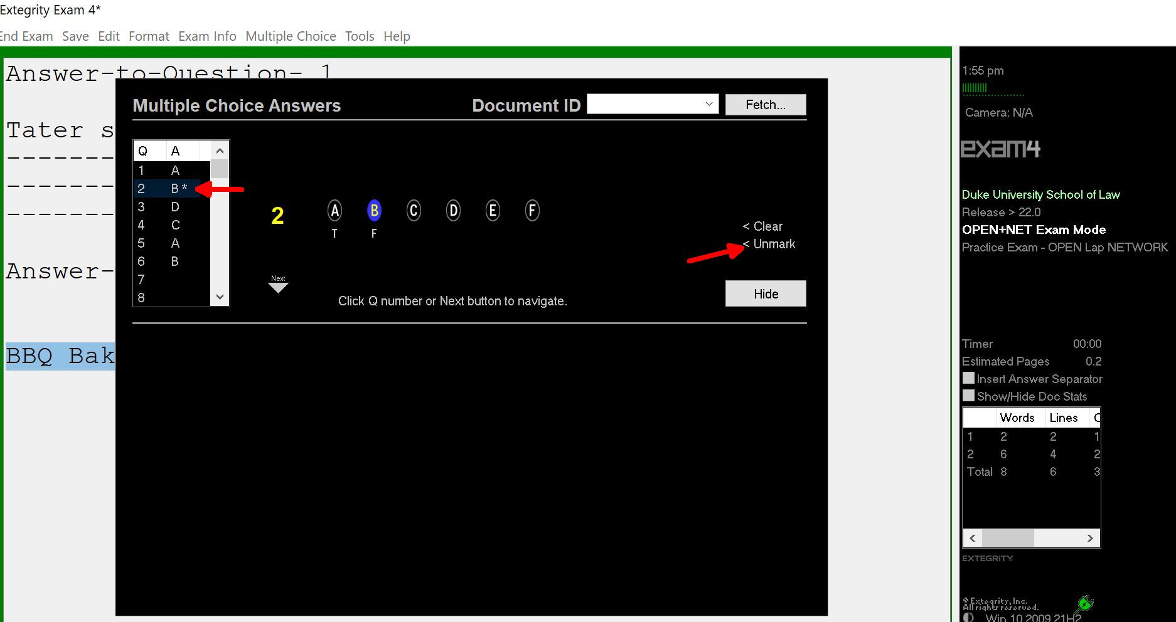

SUBMITTING YOUR EXAM
When you have completed your exam and are ready to submit your answers, navigate to “End Exam” on the top menu and click on “End Exam Now”. If you are in the multiple-choice section, click the “Hide” button first to activate the top menu. Then, end the exam. 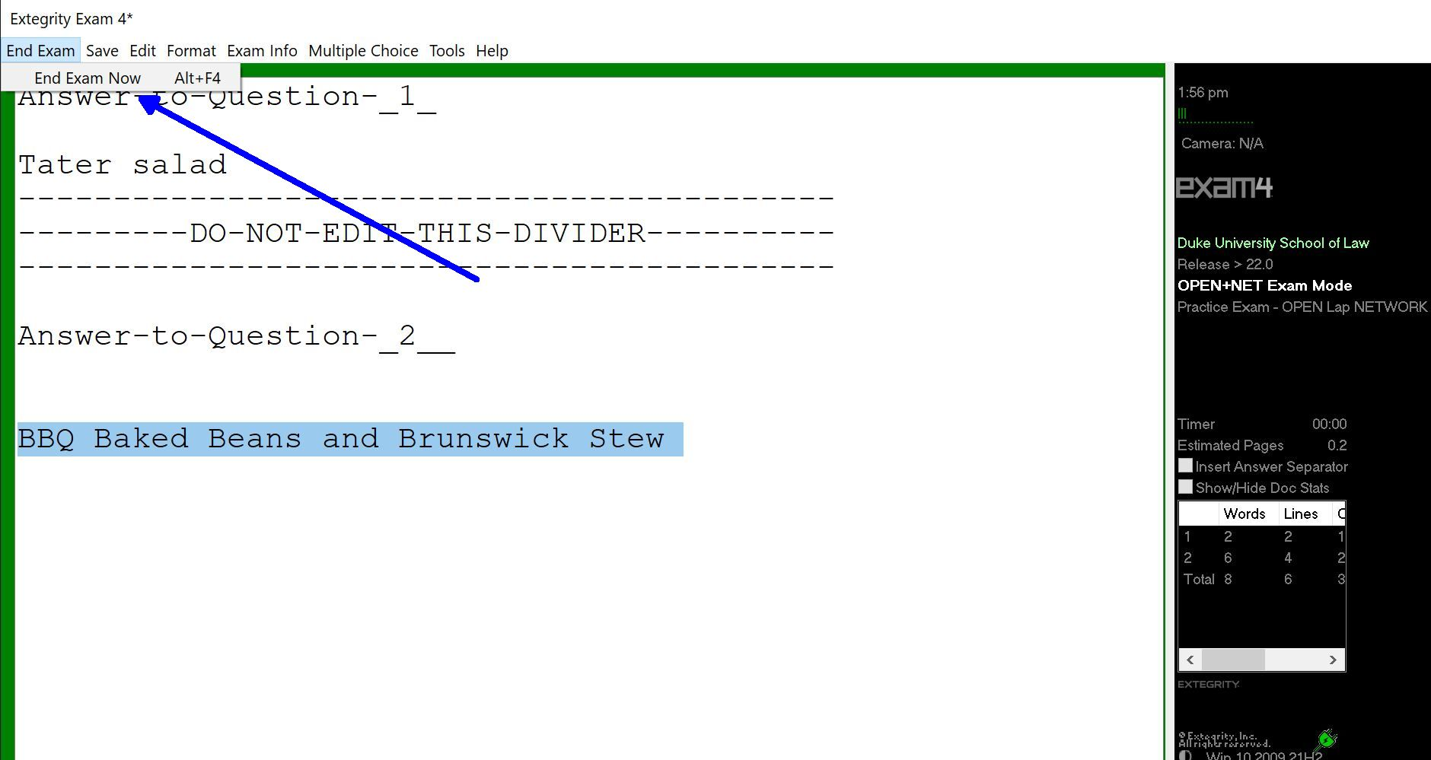
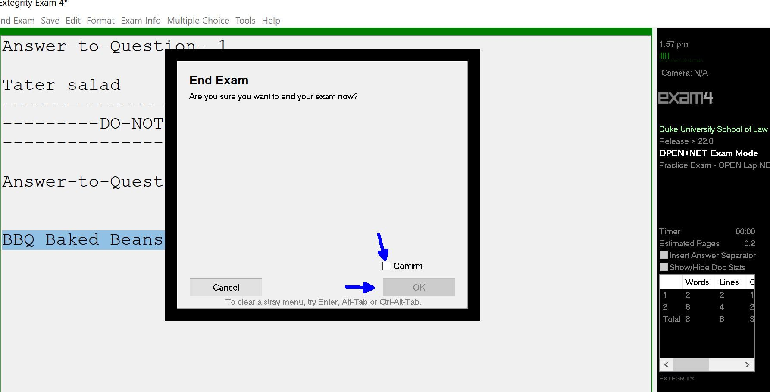
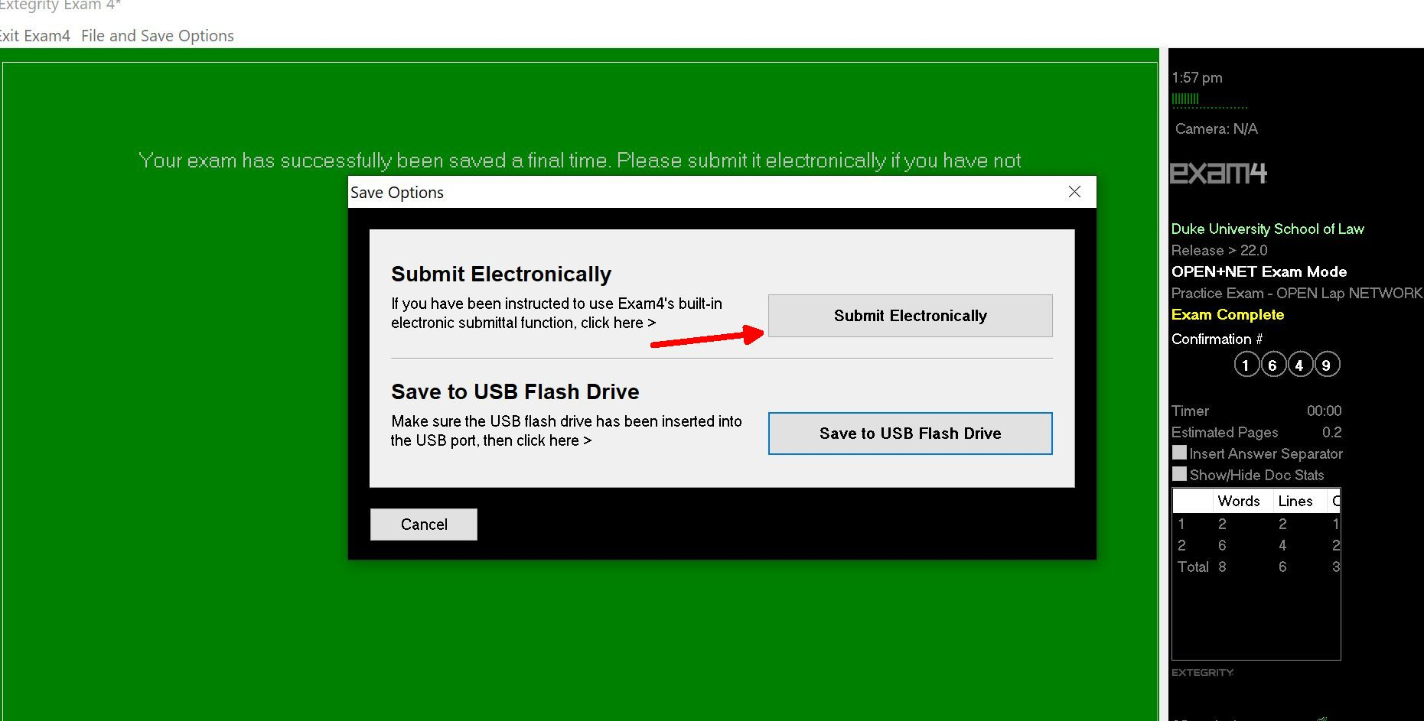
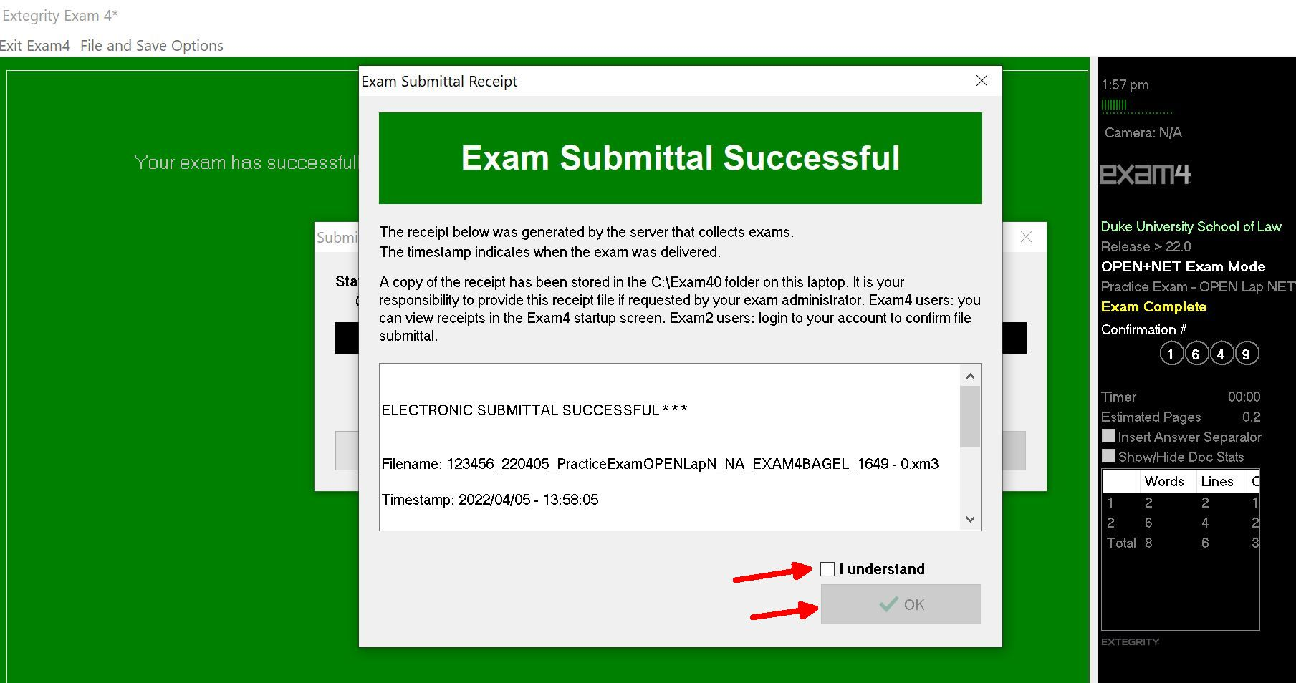
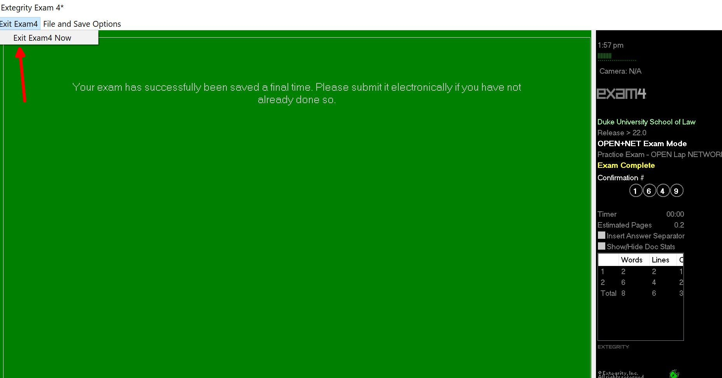
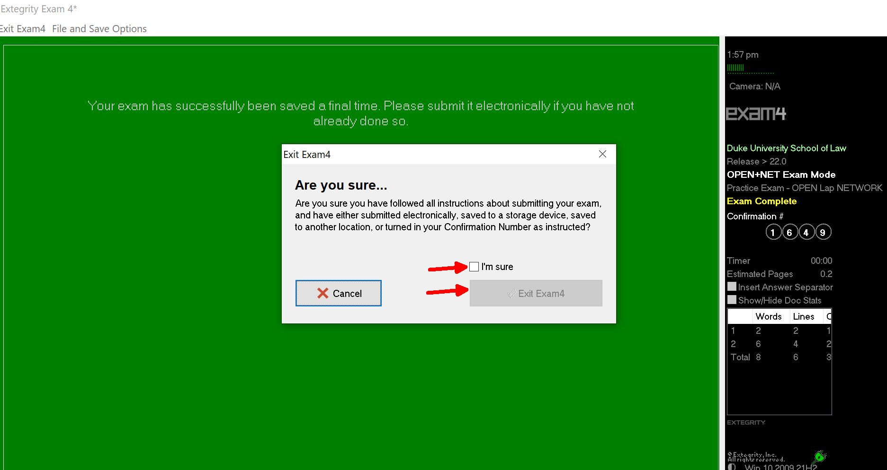

For an in-class exam, you should be preparing to submit your exam as the proctor calls the one-minute warning.
If your exam doesn’t submit, make sure that your internet is turned on. If you feel that it is taking a long time, raise your hand to alert the proctor. Duke Law Academic Technologies will be sent to the exam room to assist in submitting the exam. If necessary, the exam will be submitted to examdeposit@law.duke.edu per the steps outlined in the General Exam Instructions provided with your exam.
An exam cannot be reopened once it is submitted, they are encrypted and cannot be viewed.

TROUBLESHOOTING
If your computer crashes during the exam, raise your hand to alert the proctor if he or she is in the room. Do not restart your computer. Do not end your exam. If the proctor is not in the room, go to the Registrar’s Office in Room 2027 on the second floor of the law school. Leave your laptop in the exam room. In the Registrar’s Office you will receive a red sheet of paper and you will return to the exam room. Academic Technologies will be called to assist. If Academic Technologies is unable to restart your computer you may be required to handwrite the remainder of your exam.

