This document contains instructions for taking an Open Laptop Network Remote OR Take-Home Exam where the questions are printable. Students who have not used Exam4 should read the “How to Download and Use Exam4” document on the Duke Law website before moving forward.

STUDENTS WITH EXAMS USING TAKE HOME MODE: PLEASE READ THIS ENTIRE EMAIL. THE END CONTAINS IMPORTANT INFORMATION ON HOW TO SUSPEND THE EXAM AND RETURN TO IT LATER.

For your practice exam, you will sign into Exam4 as usual, but you will go to the Practice OpenLap Ntwrk Remote (for the Open Laptop Network remote exams) or Practice Exam Take-Home to practice your Take Home mode exam.

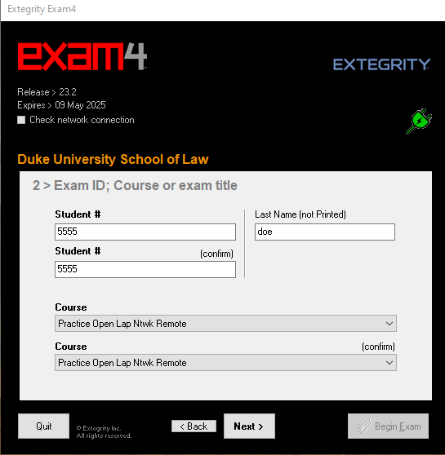

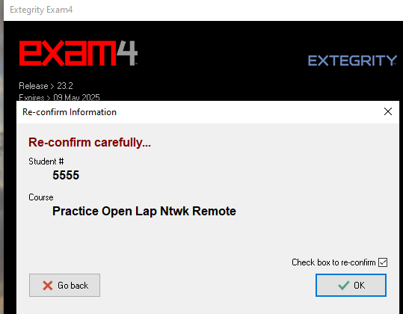

After you’ve confirmed, you’ll see the Exam Preparations screen.

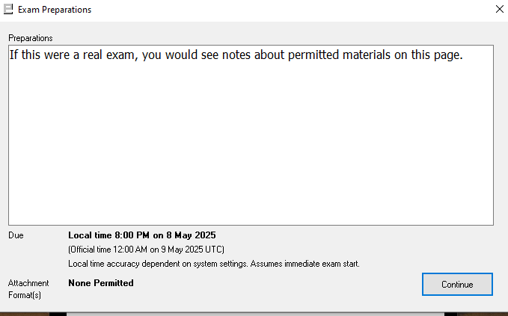

After checking details such as font size, you will move to this screen. If you are practicing an OpenLap Netwrk Remote exam or Take-Home, the type of exam will be pre-populated. Simply check the box.

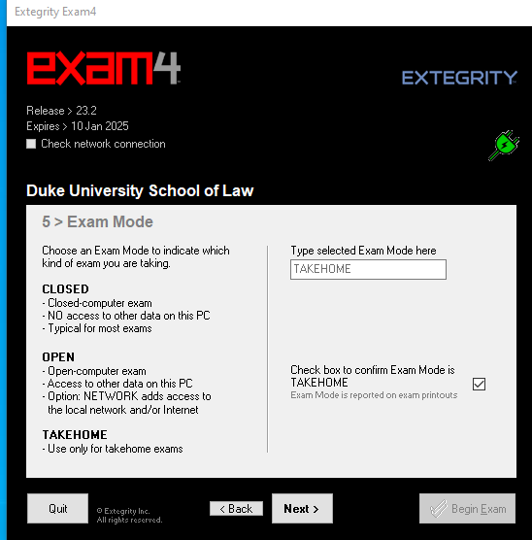

You will then reach the screen to Begin Exam.

An Exam Information Page will open on the screen. Read the instructions, then click the resources tab to find the exam questions PDF.

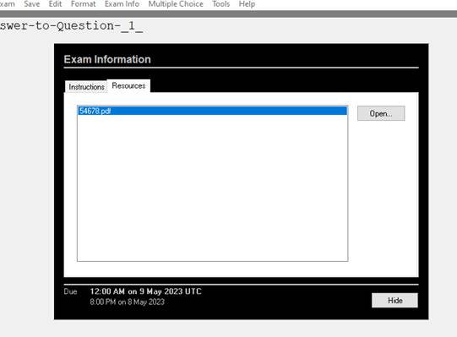

When you open the PDF, the questions will pop up. You may then print or download them. After printing or downloading, you may return to the main Exam4 screen, hit the Hide button, and begin typing in the essay window. If you need to open the questions again, you may do so under Exam Info > Remote Exam Info on the tool bar at the top of the screen.

Once the exam is open, you can use the toolbar at the top to answer the multiple choice (if any). Remember, you must close the multiple-choice tool to use the essay portion. If the multiple-choice tool is open, you must hide it in order to submit your exam.

THIS IS VERY IMPORTANT: Do not submit the exam until you have finished working on it.

Take-Home mode is used for longer exams and allows you to suspend the exam and return to it during the exam day. THE EXAMS ARE DUE NO LATER THAN 5:30 PM ON THE DAY OF CHECK OUT, unless you have an exam accommodation and are working with Student Affairs or have received other instructions.

To suspend the exam: Go to the Exit Exam4 tab at the top left of the screen.

Once you hit it, it will ask if you want to end the exam. When you click yes, it will take you to this screen:

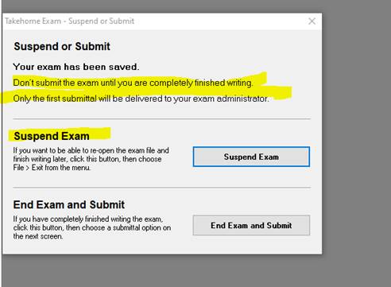

The timer will continue to run from the beginning of your exam, so be sure to note when you start the exam, and when your exam should end. If you start your exam at 8:30 AM and it is an 8-hour exam, it is due no later than 4:30, regardless of whether you take a break and return to it later. To reopen the exam, you will go back to the Exam4 start screen and choose the exam already in progress under “Select existing exam”.

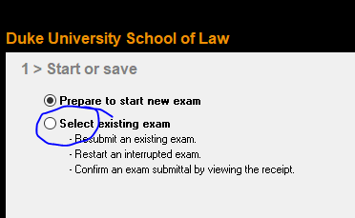

Do not end the exam and submit until you are actually finished working.

On exam day, be sure to go to your Law ______ exam in the drop/down menu. Do not take your actual exam in the practice exam documents created here.

If you have trouble with your computer or the exam software you may contact the Help Desk at helpdesk@law.duke.edu or 919-613-7072. During the exam period they are available between the hours of 8:00 AM and 9:00 PM.

